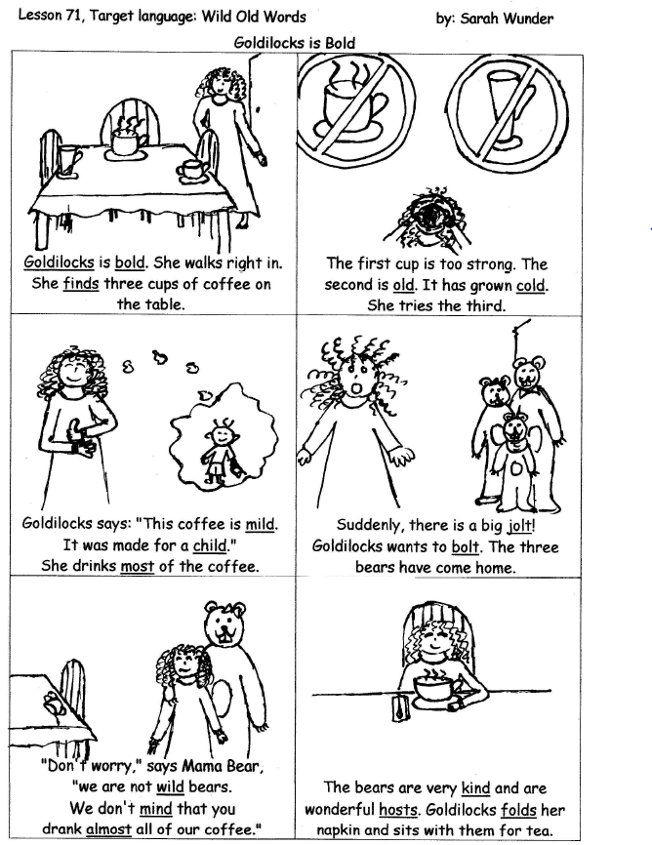
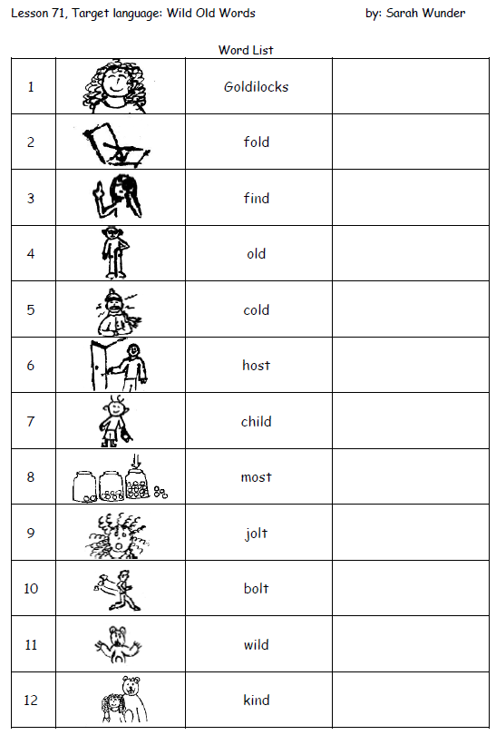

or Happy Families / Go Fish
Preparation: Cut up and glue cards onto stiff paper cards, lamination optional.
Play: There are 4 families of four cards each. The goal is to get all four cards of as many families as possible. Deal two cards per player and put the rest face down on the table. Players in turn ask, "Do you have _____ (one of the words) from the _____ family? The other player checks their hand, and either says "Yes, I do" and hands over the card or says, "No, Go Fish" and the player takes the top card from the pile. If a player gets what they ask for, they get another turn.
