Aunt Rachel Taught Shani
Aunt Rachel visited Shani on a beautiful August morning. Shani is the daughter of Rachel’s sister . | Aunt Rachel is an author of books on insects because she is an entomologist. She taught Shani to catch butterflies with a net.
Shani laughed when they saw a beautiful butterfly. She caught the butterfly in her net, as Aunt Rachel taught her. | “The butterfly’s wings have beautiful colors,” said Shani.
“But I want to set it free, because I don’t think it is good to keep it. It will only live until autumn anyway.” | Aunt Rachel said, “You are a kind girl, as I have taught you to be. You caught a butterfly - but now set it free!”

Word List
1 | 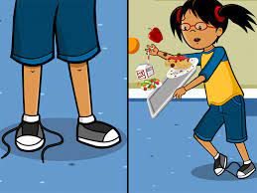 | because
2 |  | August
3 |  | autumn
4 |  | aunt
5 |  | taught
6 | 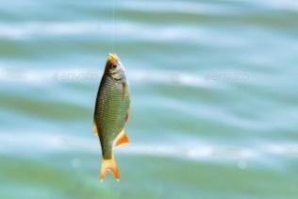 | caught
7 |  | daughter
8 |  | beautiful
9 |  | laugh
10 |  | audience
11 |  | author
12 |  | beauty

Crossword Puzzle
