Ariella’s Science Project
This is Ariella. Ariella likes science and wants to be a scientist when she grows up. | Ariella's birthday is in January. What do you think she wants for a present?
Ariella has an unusual idea. She wants a radio. A real old-fashioned radio. | Ariella wants the radio for her science project. Ariella plans on taking apart the radio.
She will keep a diary of the process. She will also create a display of all of the parts of the radio. | Ariella will present her science project at the science fair. The fair will be held in the Jerusalem theater.
Some real scientists from the Hebrew University will be in the audience. They will view Ariella’s science project!
Word List
 |  | science
 |  | scientist
 |  | January
 |  | unusual
 |  | idea
 |  | radio
 |  | real
 | 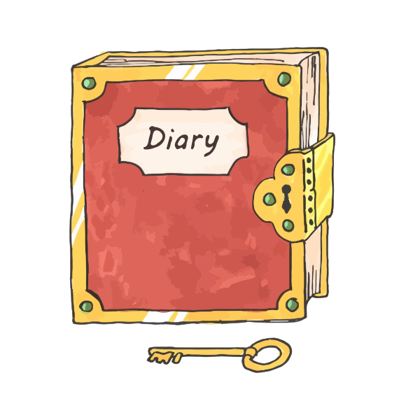 | diary
 |  | create
 |  | theater
 |  | audience
 |  | view

Dominos game for v/v words
Preparation: Glue the following dominoes onto cardboard or other three-dimensional material that can be cut into pieces. Cut out dominoes on the dotted lines only. (DO NOT CUT on the solid lines.)
Play: Mix the dominoes; each player chooses some. The first player puts one down and the other player has to put down a matching domino to complete one of the words. Read words aloud. If you don’t have a match, choose another until you find one. The first person to use up their dominoes wins.
ary | audi |  | ence | radi
o | Ari |  | ella | vi
ew | radi |  | o | unusu
al | vi |  | ew | the
ater | unusu |  | al | Janu
ary | cre |  | ate | sci
entist | the |  | ater | sci
ence | Janu |  | ary | re
al | sci |  | entist | cre
ate | sci |  | ence | ide
a | di |  | ary | audi
ence | re |  | al | Ari
ella | ide |  | a | di

