Popsicle stick game to review all possible letter combinations so far

Preparation: you need a package of popsicle sticks and a thin-tip marker.
Words:
Choose words from the lesson you have reached, from the word list, yellow cards, and story.
Write individual consonants, consonant digraphs, and consonant blends for a word at both ends of a popsicle stick, leaving out the vowel or vowel team. (For magic-e words, you would need to add the silent e after then final consonant sound.)

Vowels:
Make vowel s on handles – cut a popsicle stick into pieces, and write the vowel on the center piece. Glue a handle on the back so you can move the vowel around (use one end of the popsicle stick, glue it to the back of the vowel at right angles). Use all vowels learned so far (may be individual vowels or vowel teams).

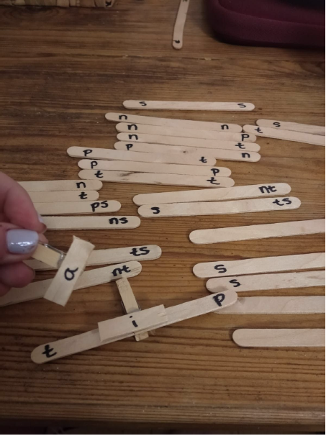
Play: You say a word, the student assembles the word from the vowel and consonants. Or, have the student choose vowel and consonants and read the assembled word.
*Some consonants may have more than one vowel option (sit/sat).

