Pit's Tins
Pit spins pins in tins.  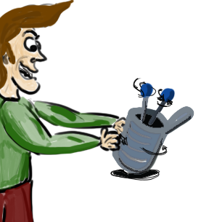 | I sit.  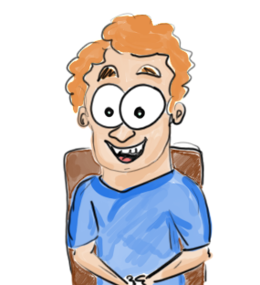
Pit spits pits in tins.  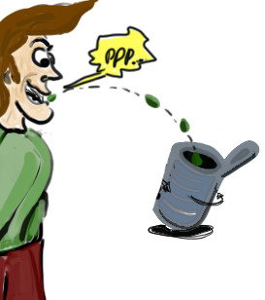 | It isn't I. It's Pit.  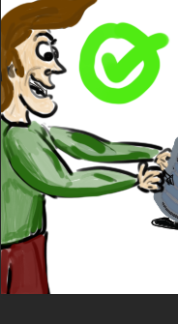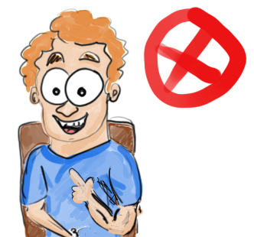
I tip Pit's tin in pit.  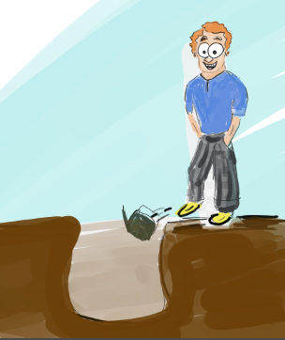 | It's Pit's tin.  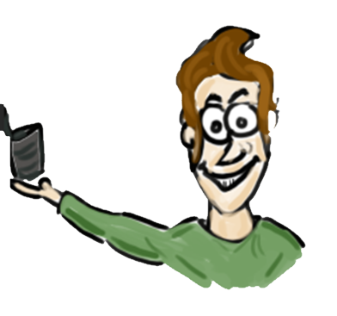
Word list
 | pin | 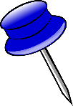
 | pins | 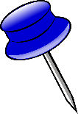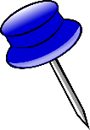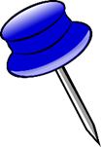
 | spin | 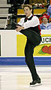
 | pit | 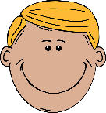
 | pits | 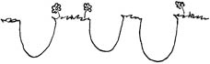
 | tin | 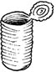
 | tins
 | sit | 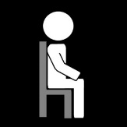
 | spit | 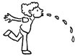
 | in | 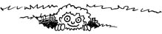
 | I | 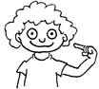
 | it's | It is

Scrabble
Instructions: Cut up the gray letter tiles, and prepare the board (below).
- Start from the middle of the board (one of the yellow squares).
- Use the five letters of lesson one to write as many words as possible on the board.
- The following word must use one of the letters of the previous words on the board.
- The longer the word is, the more points you get.
  - Two points for a two-letter word.
  - Six points for a three-letter word.
  - Twelve points for a four-letter word.
  - Twenty points for a five-letter word.
- Use the word list for suggested words.

S | N | I | P | T | S | N | I | P | T
S | N | I | P | T | S | N | I | P | T
S | N | I | P | T | S | N | I | P | T
S | N | I | P | T | S | N | I | P | T
S | N | I | P | T | S | N | I | P | T
S | S | I | ' | t | S | S | I | ' | t
S | S | I | ' | ' | S | S | I | ' | '

