Miriam’s Time Travelling Adventure
Miriam is a curious, adventurous girl. | When she got the marvelous opportunity to go time travelling, she was thrilled.
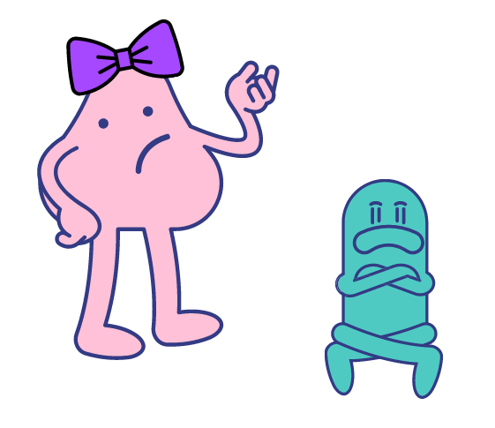  Her brother was jealous because he wanted to go, too. Miriam thought that was ridiculous because her brother was too little to go time travelling. | Obviously, Miriam was nervous. It was going to be an enormous experience.
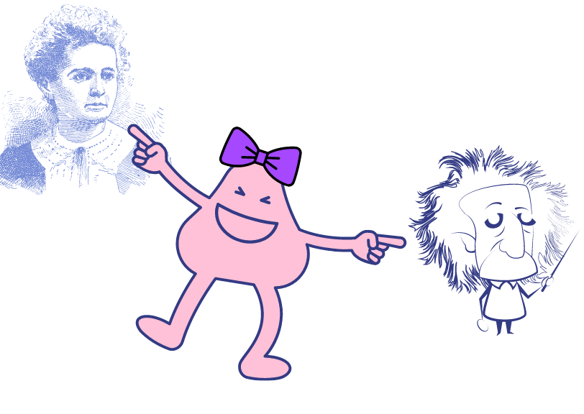  Miriam planned to travel to see various people, like Madam Curie and Albert Einstein, who were famous scientists. | She wanted to see serious events and joyous celebrations from history. What would you want to see if you went time travelling?

Word list
 |  | curious
 |  | adventurous
 |  | marvelous
 |  | jealous
 |  | ridiculous
 |  | obvious
 |  | nervous
 |  | enormous
 | 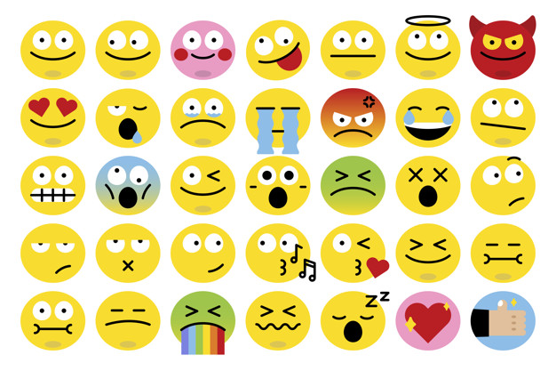 | various
 |  | famous
 |  | serious
 |  | joyous

Word Search for words ending in "ous"
E U C R L N V C R E V E T Y P E T G S C
Y X A I O E C U R I O U S T Y G I K Y W
D U R D X L Y T K R X Q T C S Q S P J L
F T V I V T N U G M T O Z U V C U A E U
A Q P C G E O U T N F W O H L G O M A K
M S J U N A N Q B S C I P O G F I S L Z
O W O L M O P T L Y R J F V Y E V D O W
U G Y O E N Y K U A E T H S I K B Q U P
S E O U T Z C D V R G O N E R V O U S E
F Z U S B D L I P L O U A R T H O R Q X
A K S V U R Y E L A L U B I C U O V S T
Y J A D M A R V E L O U S O V K E Z F D
I O I J Y H T G F R F E D U W Q A M X U
S F V U K A E N O R M O U S U W Z P Q C

Words to find:
adventurous, curious, enormous, famous, jealous, joyous, marvelous, nervous, obvious, ridiculous, serious, various

Answers:
E U C R L N V C R E V E T Y P E T G S C
Y X A I O E C U R I O U S T Y G I K Y W
D U R D X L Y T K R X Q T C S Q S P J L
F T V I V T N U G M T O Z U V C U A E U
A Q P C G E O U T N F W O H L G O M A K
M S J U N A N Q B S C I P O G F I S L Z
O W O L M O P T L Y R J F V Y E V D O W
U G Y O E N Y K U A E T H S I K B Q U P
S E O U T Z C D V R G O N E R V O U S E
F Z U S B D L I P L O U A R T H O R Q X
A K S V U R Y E L A L U B I C U O V S T
Y J A D M A R V E L O U S O V K E Z F D
I O I J Y H T G F R F E D U W Q A M X U
S F V U K A E N O R M O U S U W Z P Q C

Words to find:
adventurous, curious, enormous, famous, jealous, joyous, marvelous, nervous, obvious, ridiculous, serious, various

