Mr. and Mrs. Nike
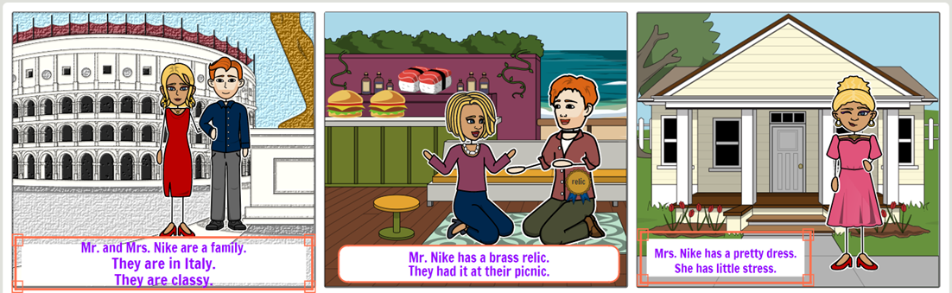

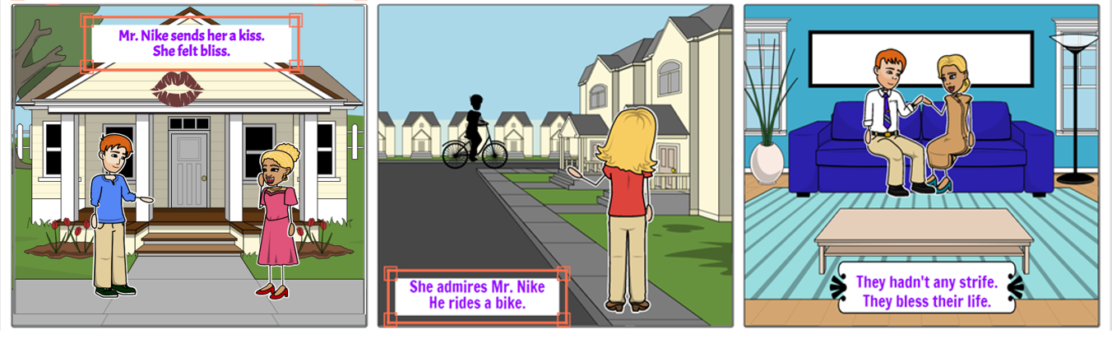

Word List
1 |  | classy
2 |  | brass
3 |  | dress
4 |  | stress
5 |  | kiss
6 |  | bliss
7 |  | bless
8 |  | family
9 |  | bike
10 |  | relic
11 | 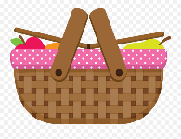 | picnic
12 |  | Italy

Memory Game: Match the picture card to the word card.
Game instructions: Scatter all the cards face down on the table.
Each player in turn, reveals a card and tries to find the twin card he turned over with the card face up. If he finds the matching card, he wins them. If not, he returns them upside down on the table. The winner is the player who collects the largest number of cards.

classy
brass
dress
stress
kiss
bliss
bless

Missing Letters: Match the correct letters to complete the word.
Game instructions: Cut out the circles of the letters, Glue the letters you cut, in the correct circles of each word. Complete the missing letters.
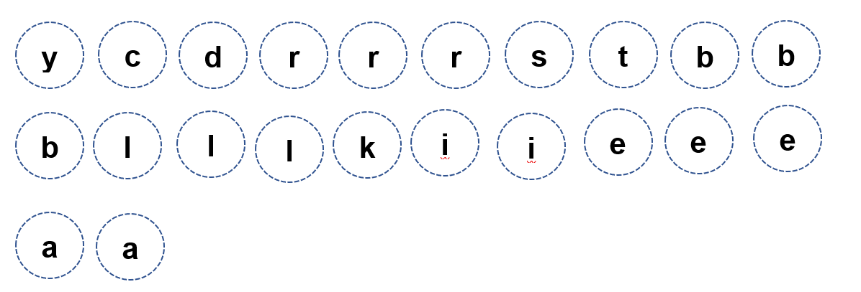
Letter Bank:

ss
ss
ss
ss
ss
ss
ss

