Think of Three Things
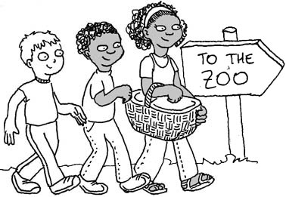  Ned, Mike, and Franny think it’s a good day to go to the zoo.  They take a picnic basket with them. | 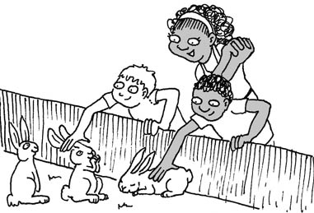  At the zoo, the kids see lots of animals. “Look at these rabbits! ” They pet them.
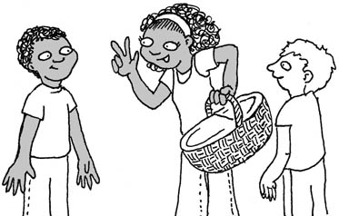  Franny said, “There are three things in the basket. These three things are good. You’ll like them. They are…” | 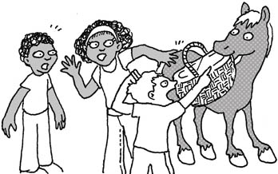  But just then….a pony stole their basket!  “Help, help! A pony took the basket!” yells Ned.  ”Get that pony!”
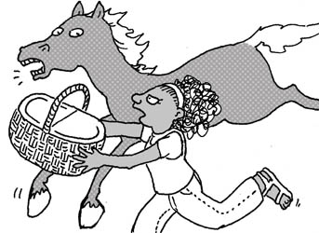  Franny ran. She got the basket.  ”Silly pony, this basket with these three things inside is not for you!” | 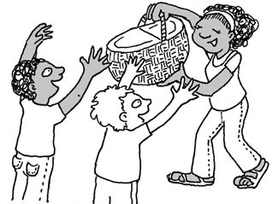  “Thanks, Franny!” Both Mike and Ned are glad she got their basket back from the pony.  What three good things do you think  are in the basket?

Word List
1 | 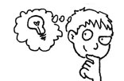 | think
2 | 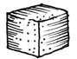 | thing
3 | 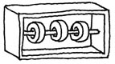 | three
4 | 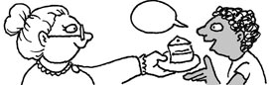 | thanks
5 | 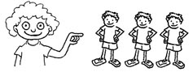 | they
6 | 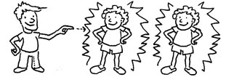 | them
7 | 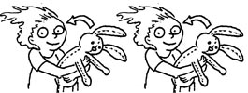 | their
8 | 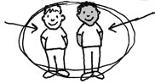 | both
9 | 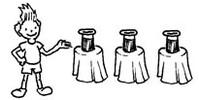 | these
10 | 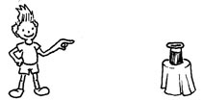 | that
11 | יש | there are
12 | 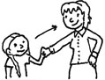 | with

Game
Game: Happy Families (Go Fish)
Preparation: Cut out and glue the cards onto heavy paper, lamination optional.
To play: Shuffle the cards. Deal each player four cards and put the remaining pile of cards face down in the middle. Players try to assemble families of four cards by asking the other player(s) for the card they want by name (example: “Do you have “hen” from the H family?”) If the player gets what s/he requested, she gets another turn. If not, the other player says, “No, Go Fish” and the first player draws a card from the pile. Lay down each family of four cards as it is assembled; the learner should read the 4 words and state their meanings. Play until all the cards are laid out in families. The player with the most families wins. (Try to let the learner outsmart you.)

thi-  think  thing  thin  this | thi-  thing  think  thin  this | thi-  thin  think  thing  this  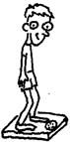
thi-  this  think  thing  thin  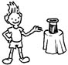 | the-  they  them  their  these | the-  them  they  their  these

the-  their  they  them  these | the-  these  pit  pan  pins | tha-  thanks  that  than  thankful
tha-  that  thanks  than  thankful | tha-  than  thanks  that  thankful  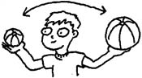 | tha-  thankful  than  that  thanks  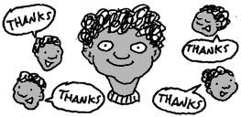
-th  with  both  bath  math | -th  both  with  bath  math | -th  math  with  both  bath  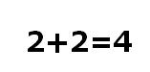

-th  bath  with  both  math  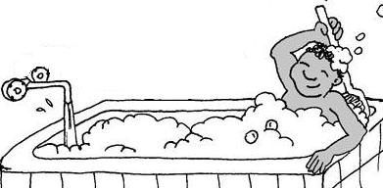 | mid- th  nothing  something  anything  clothes   | mid- th  something  nothing  anything  clothes  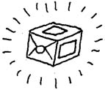
mid -th  clothes  nothing  something  anything  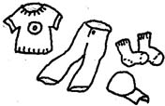 | mid -th  anything  nothing  something  clothes  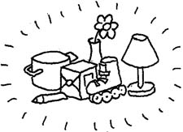 | more th  three  those  throne  the
more th  those  the  three  throne  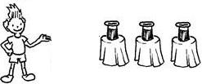 | more th  throne  the  those  three  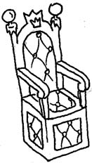 | more th  the  throne  those  three  ה-

