The Cat and the Cake
Dana bakes a cake.  It is a banana and berry cake.  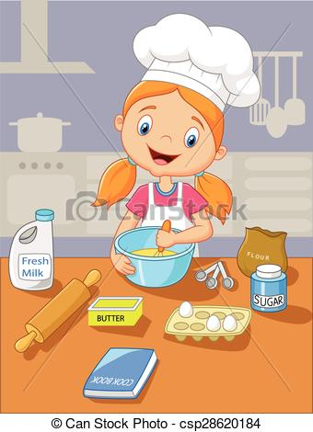 | Kate helps Dana make the tasty cake pastry.  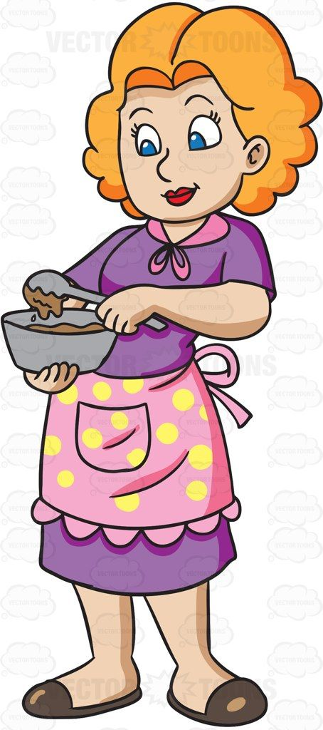
The cat smells the cake. Mmm!  Can she taste the cake?  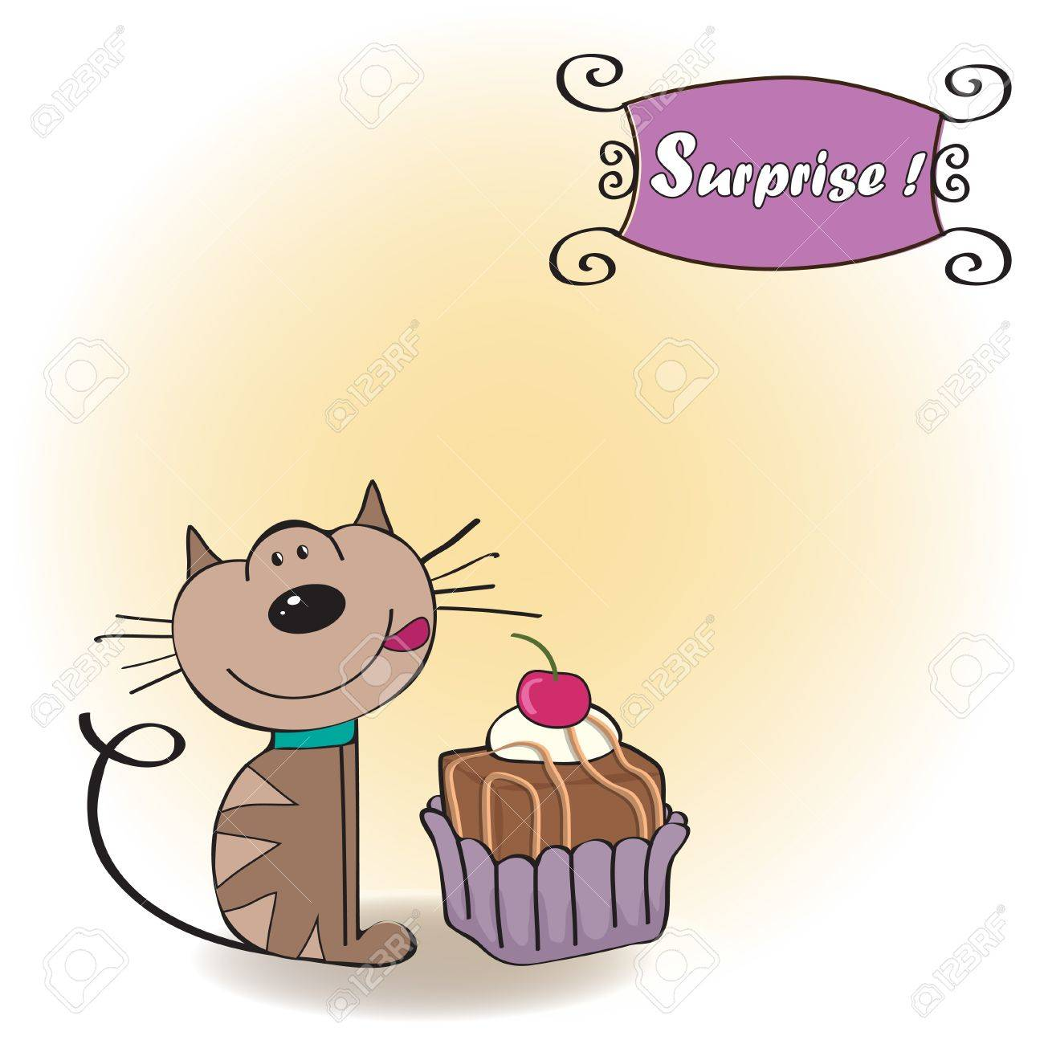 | The cake plate is tall and can tip!  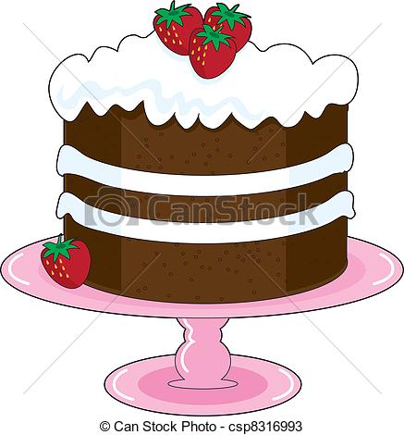
The cat kicks the cake by mistake.  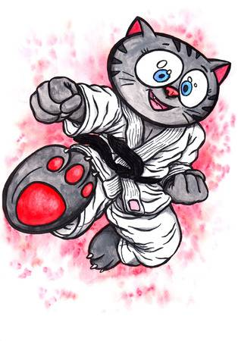 | Dana's cake is in a bad state.  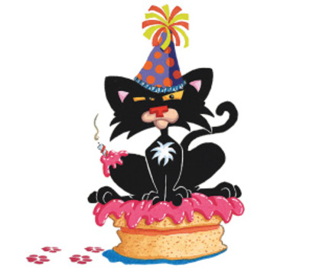
Kate takes the cake. It is like a red lake!  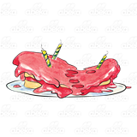 | Dana is sad. This cat has 4 "left hands."  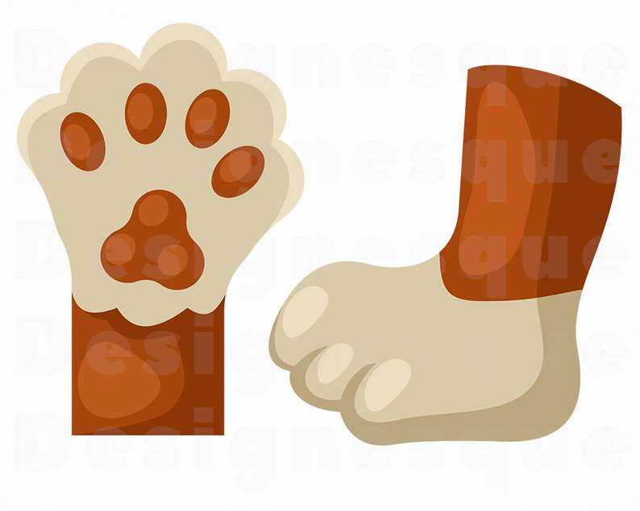

Word List
1 | 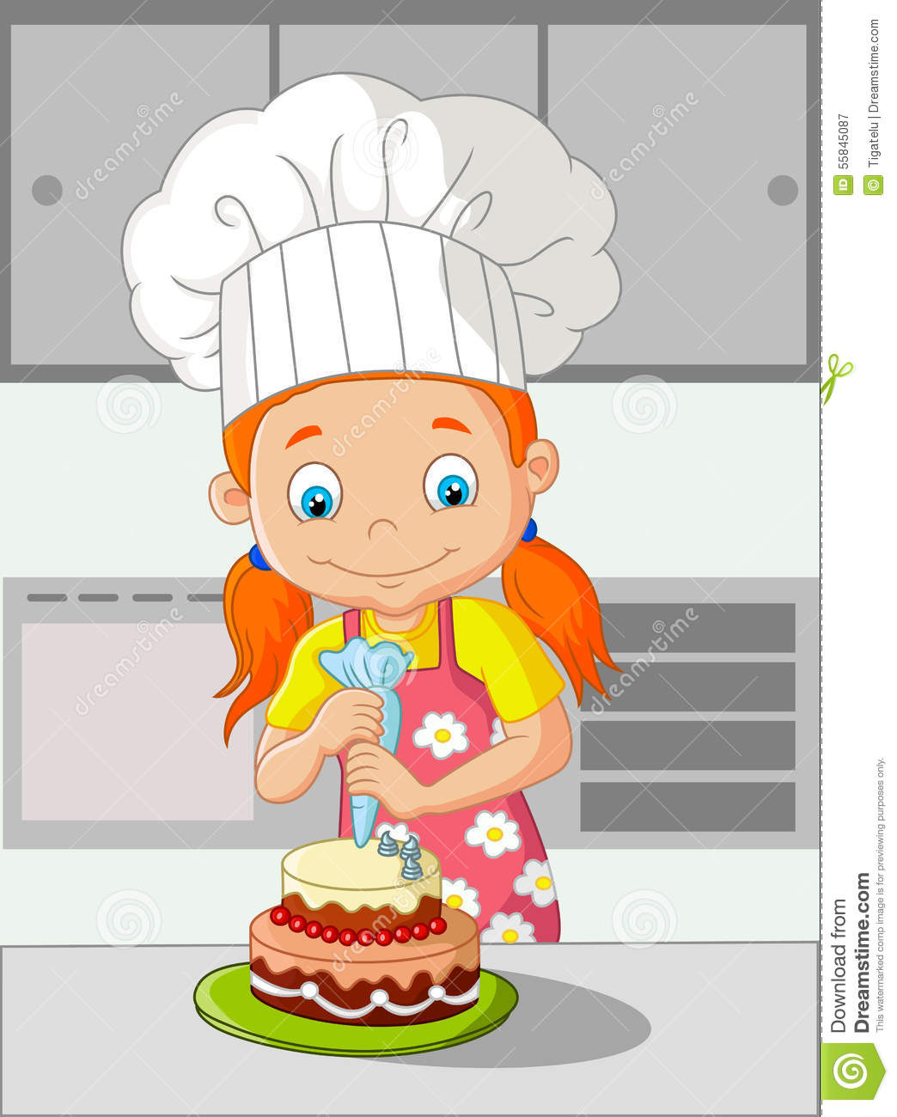 | Dana
2 |  | Kate
3 |  | bakes
4 |  | cake
5 |  | cat
6 |  | kicks
7 | 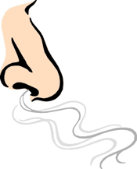 | smells
8 |  | hands
9 |  | left
10 |  | plate
11 | 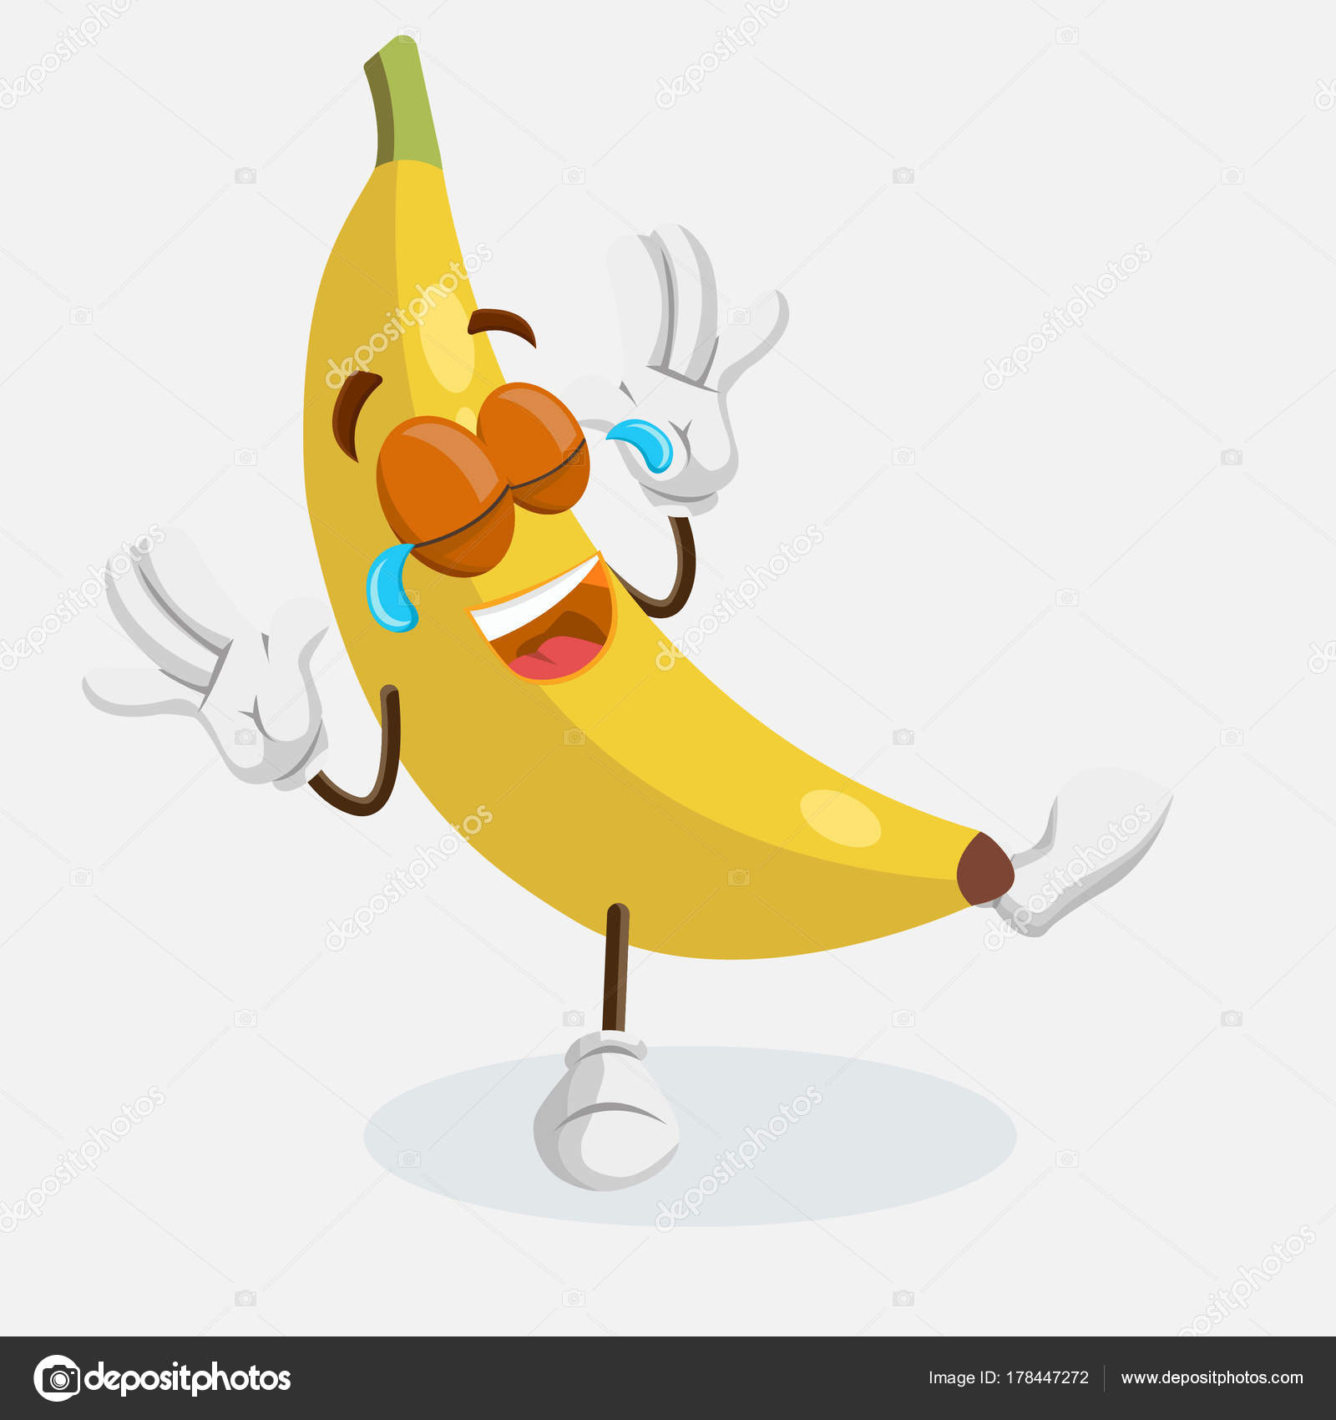 | banana
12 | 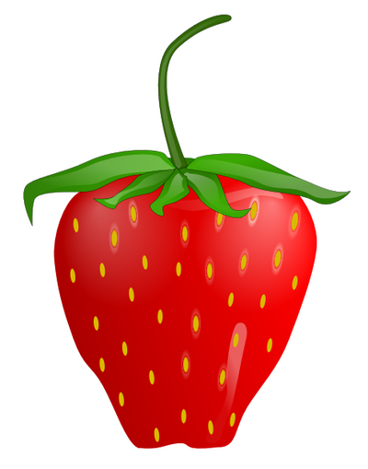 | berry

Word Search

L | M | J | E | K | A | C | C | H | D | U | P
E | R | K | B | Y | R | R | E | B | M | D | O
F | J | A | N | A | N | A | B | S | O | A | P
T | K | C | I | K | H | I | A | M | T | N | L
J | R | M | C | X | C | E | K | E | H | A | A
A | V | C | A | Z | X | R | E | L | E | O | T
F | T | U | T | G | L | E | R | L | R | E | E
M | S | D | N | A | H | O | I | B | D | W | K

Find the following words in the puzzle.
Words are hidden and .

BAKE
BANANA
BERRY
CAKE
CAT
DANA
HANDS
KICK
LEFT
MOTHER
PLATE
SMELL

