Kate and Kim
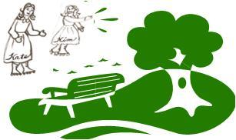  Kate and Kim met in the park  in their skates. | 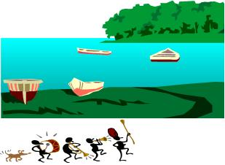  There is a lake in the park  A parade is at the lake.
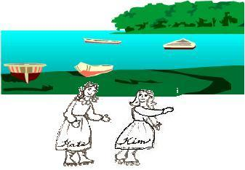  They skate happily by the lake. | 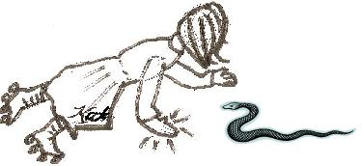  There is a snake in their path!  Kate hates snakes! Kate panics!  Kate falls and scrapes her hand.
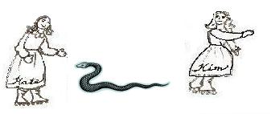  Kim skates by. "Kate, let's skate!  The parade!" she calls back.  Kate skates by the snake. | 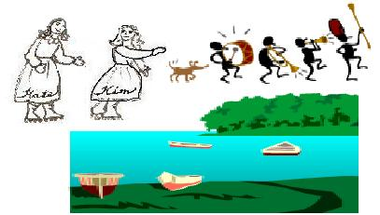  The parade by the lake is terrific!
Word List
1 | 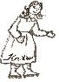 | Kate
2 | 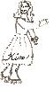 | Kim
3 |  | park
4 | 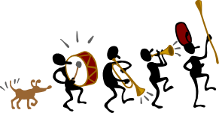 | lake
5 | 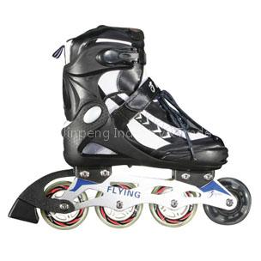 | skate
6 | 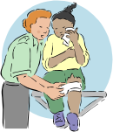 | scrape
7 |  | parade
8 |  | snake
9 |  | panic
10 |  | terrific
11 |  | happily
12 | 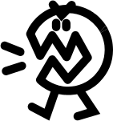 | hate

Game: Skate with the a_e
To make the game: Print. Glue board, letters, and skate scoring pieces on Bristol.
Glue instructions on back of board. (Laminate.) Cut out board, letter cards in small squares, skates for keeping score.
To play: This is a game for two players. Each player chooses whom he wants to be: Kate or Kim. Each has a lane on the board to "skate" in. Player will place a skate in his/her lane for each a-magic-e word he makes. Place the board face-up on the table, and place the letter cards facedown between the players. Take turns picking up two letters and placing them on the chart to make words. If the player makes a "legal" word, he can place a skate on his lane. The game ends when all the letters are used. Count the skates; the player with the most skates wins. To shorten the game, you could agree that the first
player to reach 6 skates in the lane wins.

 | a |  | e
Kate
Kim
Skate with -a_e
Letters to cut up
c | h | p | n | n | h | m | k
c | k | r | h | b | t | r | r
f | l | s | s | r | n | d | d
f | m | t | b | h | l | p | s
Player’s skates - Kate:
Kim
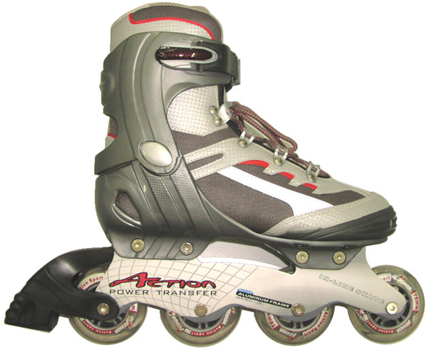
,
fate, bake, take, hate, lake, lane, make, late, date, rate, safe,
fame, name, tale, pale, sale, male, tame, rate, Nate, cake, rake

Some possible words to use:
a_e words
We have not yet learned the (s) sound of c but legal words ending in "-ce" are in parentheses
B: bake, bale, bane, base, bate
C: came, case
D: dare, date
F: fate, fame, fake, (face)
H: hale, hare, hate
K: kale, Kate
L: lake, lame, lane, late, (lace)
M: make, male, mare, mate, (mace)
N: name, Nate
P: pale, pane (pace)
R: rake, rate, (race)
S: safe, sake, sale, same
T: take, tale, tame

