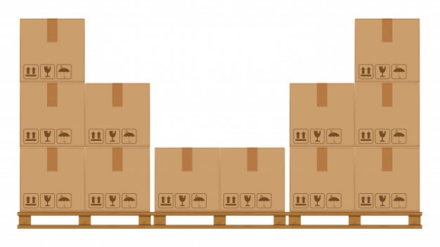Boxes of Gold

|  |  |
| --- | --- |
| Collection of shops and stores Free Vector  gold        Illustration set of cute and nice old people couples on white background. man and woman speaking and walking, smiling and standing together, friends, handsome old men in cartoon flat style. Premium Vector  Flat icons set of old lady with bag Free Vector          Kind Rose and old Jim sold boxes  of gold in their store. | GOLD      Set of paper yellow boxes for packing goods Premium Vector        Rose said, "Hold these boxes, fold them and put them there.” |
| Cardboard boxes carton collection Premium Vector  Background of snowy landscape through a window Free Vector          Cashier with buyer and seller with computer screen desk table with modern flat style Premium Vector  cashier        Jim said, "Today it is not a mild day, it is a cold day. People will come  to find the store in the morning." | Set of clouds in sky Free Vector    Equestrian sport icon set Free Vector    gold    Cute cartoon horse racing character. sport character cartoon. Premium Vector      Two women and a wild child rode on colts  to the store  Collection of shops and stores Free Vectorto buy most of the boxes of gold. They said "Give us ten boxes of gold." |
| Collection of shops and stores Free Vector  gold  Set of clouds in sky Free Vector      Crate boxes on wooded pallet Premium Vector    Set of multicultural kids character Free Vector  Crate boxes on wooded pallet Premium Vector        The women paid and took their gold, then said, "Thanks, we will bolt the door." They left the store. | Set of clouds in sky Free Vector                sold    closed      Rose said to Jim "we have sold most of our gold. We can close our store." |

Word List

|  |  |  |  |
| --- | --- | --- | --- |
| 1 |  | old |  |
| 2 |  | cold |  |
| 3 |  | sold |  |
| 4 |  | fold |  |
| 5 |  | gold |  |
| 6 |  | mold |  |
| 7 |  | hold |  |
| 8 |  | colt |  |
| 9 |  | bolt |  |
| 10 |  | post |  |
| 11 |  | roast |  |
| 12 |  | child |  |



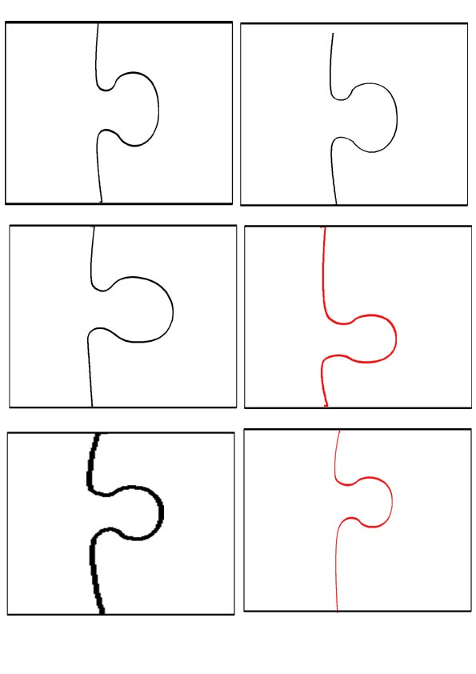

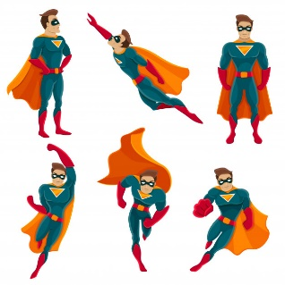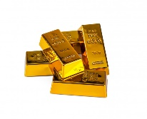

gold

old

cold

child

fold

sold

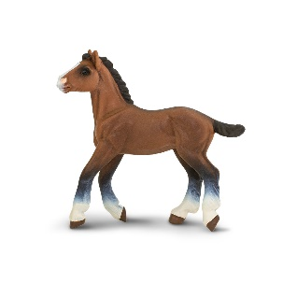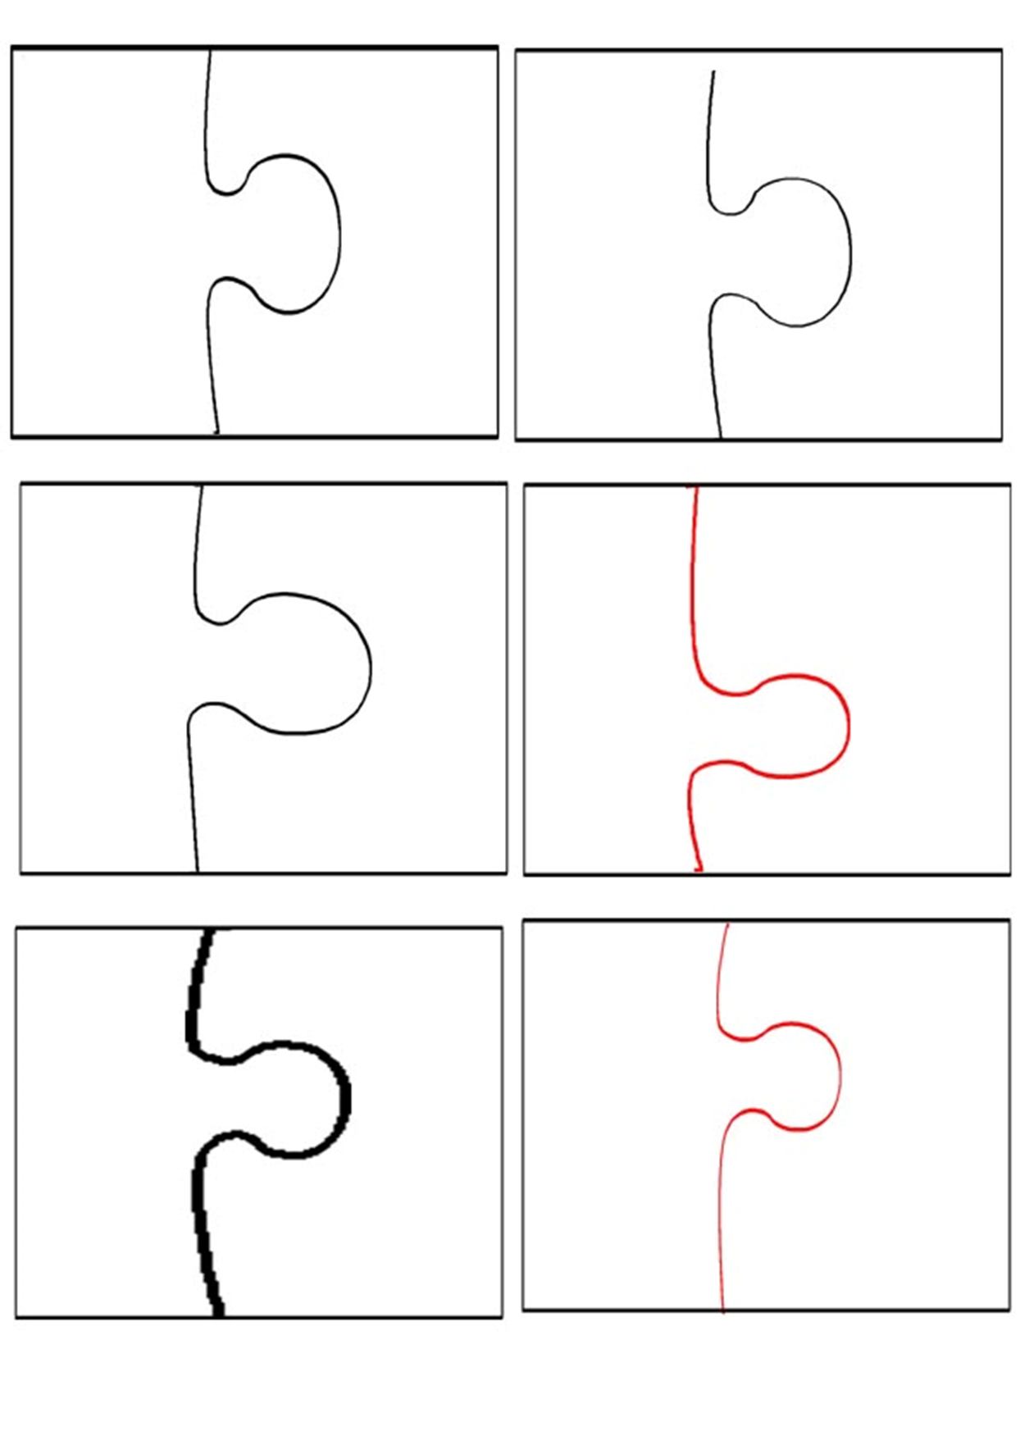



hold

roast

post

mold

bolt

colt