The Missing Key

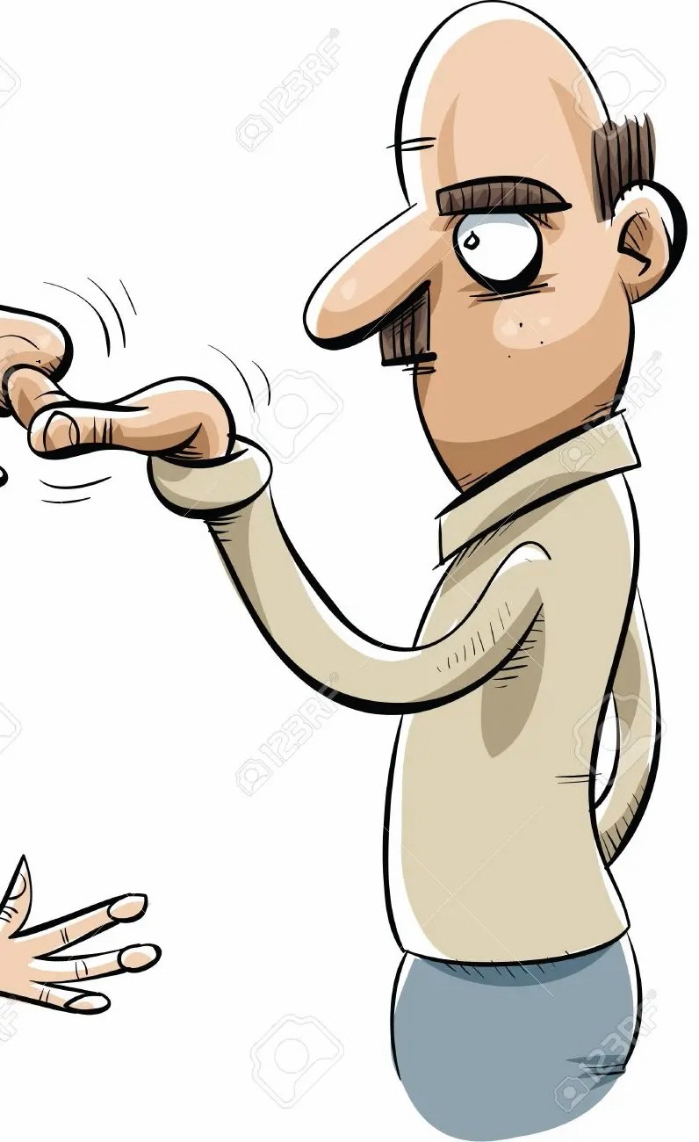
Kelley and Audrey’s parents went on a vacation to Turkey, leaving the two sisters home alone for a week. | One day, Kelley  came home from  school and couldn’t  find her key to the  house. Since  Audrey was still at  school, she phoned  Uncle Mickey who  invited her to  come for lunch  until Audrey returned.
Just then, Barney, their  nosey neighbor, approached Kelley  and joked that she could always go down the chimney! | Kelley told him she was  going to her Uncle Mickey’s  house for lunch to wait there  for Audrey.
Uncle Mickey was a great cook and always made special meals.  Today he was making roasted  turkey and barley stuffing with  garlic and parsley.  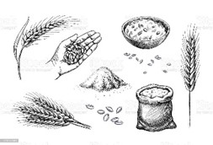 | Kelley liked to  visit Uncle Mickey  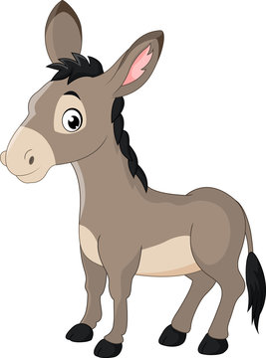  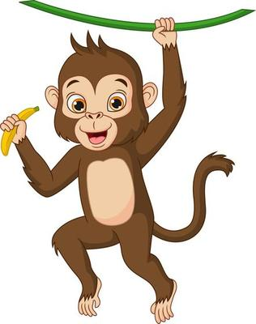  because he  had a lot  of pets, including,  dogs, cats,  fish, a donkey,  and even a  monkey called  Shirley.
When Kelley arrived, Uncle Mickey was  watching television. He greeted her  as always by giving  her a small bag of chocolate coin money. | An hour after eating lunch,  Audrey arrived and the two sisters thanked Uncle Mickey  and left for home. Happily, Kelley’s missing key was  found on the  kitchen table  next to the  honey jar.
Word List
1 |  | Turkey
2 | 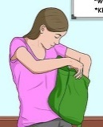 | Kelley
3 |  | key
4 |  | chimney
5 |  | nosey
6 |  | Mickey
7 | 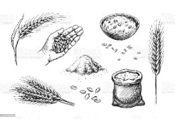 | barley
8 |  | parsley
9 | 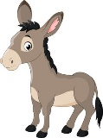 | donkey
10 |  | monkey
11 |  | money
12 | 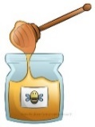 | honey

Online Wordwall game
https://wordwall.net/resource/57610136/lesson-88-hickey-game
Bingo Game
What to do in advance:
Print out pages and laminate squares (picture/word) and bingo cards.
Cut out the squares.
Cut out bingo cards.
Bring small chips or coins for players to mark the spaces on the bingo card.

How to play:
- Place all the squares (picture/word) in a hat, bucket, small box or bag and mix them up.
- Give each player a bingo card.
- Decide in advance if the object of the game is to get a full line (vertical, horizontal, or diagonal) or a full card.
- The caller picks a square without looking and reads the word or names the picture.
- Players mark the bingo card with a chip when the picture/word that appears on their card is chosen.
- Players are to shout "BINGO!" when they get a full line (vertical, horizontal, or diagonal) or a full card.

Squares to cut out and put in a bag, etc.
Turkey |  | Kelley
key |  | chimney
nosey |  | Mickey
barley | 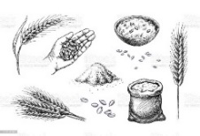 | parsley
donkey |  | monkey
money |  | honey | 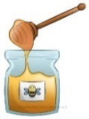

Bingo card 1
chimney
Turkey
key
monkey
honey
parsley
money
nosey
donkey
barley
Mickey

Kelley
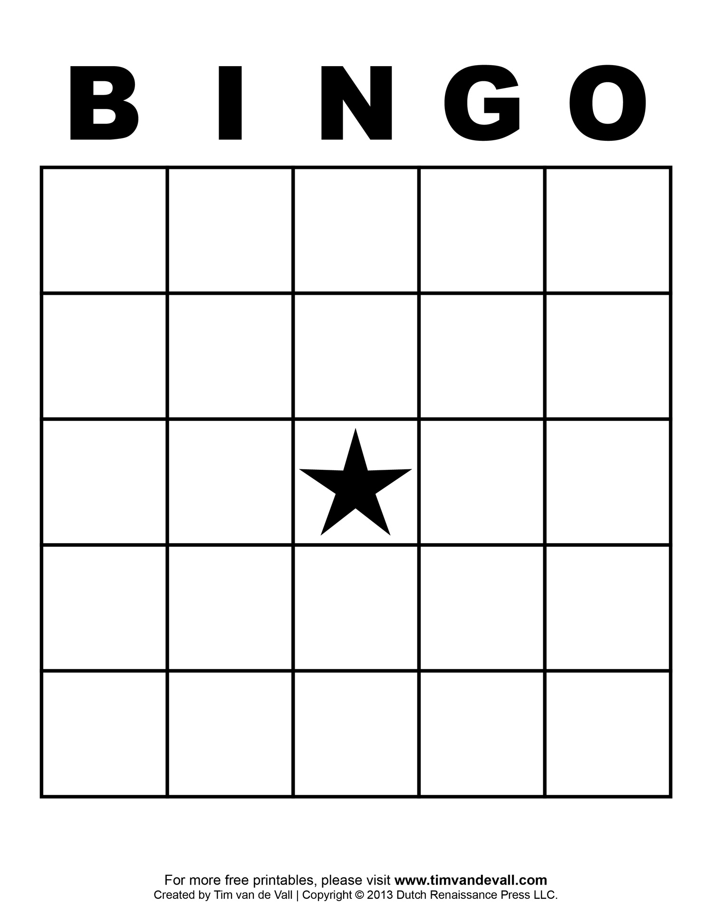

Bingo card 2

parsley
money
Turkey

Mickey
nosey

donkey
Kelley

honey
barley
monkey

key
chimney

Bingo card 3
key
parsley
honey

barley

Turkey

monkey
donkey
Mickey
Kelley
chimney
money
nosey

Bingo card 4

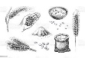

monkey
Kelley
money
honey

chimney

key

parsley

donkey
Mickey
nosey
barley

Turkey

Bingo Card 5

monkey
Kelley
money
honey

chimney

key

parsley

donkey
Mickey
nosey
barley

Turkey

