Kate and Tim
This Photo by Unknown Author is licensed under CC BY-NC-ND  Kate is ten! Tim is her best friend.  Tim calls all Kate's class friends – shhh! | Tim bakes a cake – mmmm.  All Kate's friends are at Tim’s.  Kate isn’t there yet!
Tim didn't tell Kate. Kate is late!!  It's a shame! | 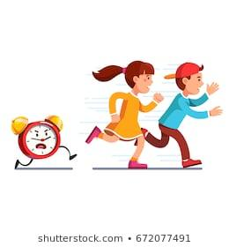  Kate is at the mall, there’s a sale!  The sale has made her late
Tim calls Kate, then she came.  She is happy! Her friends are all there at Tim's! | Kate was late. All her class friends ate Tim's cake – mmmm.  Tim is a fine best friend!
Word List
1 |  | Kate
2 |  | bake
3 |  | cake
4 |  | ate
5 |  | came
6 |  | late
7 |  | shame
8 |  | sale
9 |  | call
10 |  | mall
11 |  | class
12 |  | happy
Game:
Preparation: Cut out the picture cards and the sentences (answers listed, but remove them).
Play: 1. Place the picture/s in the correct order they appear in the story.
- Match the picture with the correct sentence.

Answer: Tim calls Kate, then she came. | Answer: Tim tells all Kate's class friends – shhh!
Answer: Tim bakes a cake – mmmm. | Answer: Kate is late!! It's a shame!
Answer: Kate is at the mall, there’s a sale! The sale has made her late | Answer: Kate was late. All her friends ate cake –mmm!

Place the sentence with the correct picture.
- Tim tells all Kate's friends, shhhhh.
- Tim bakes a cake - mmmmm.
- Kate is late. It's a shame.
- Kate is at the mall, there's a sale!
The sale has made her late!
- Tim calls Kate. Then she came.
- Kate was late. All her friends ate cake –mmm!

