Lesson 32, Target letters: nk by: Shir Guetta and Shir Israel

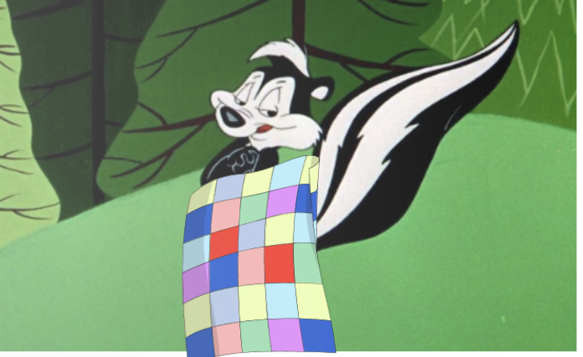

The Skunk in the Blanket

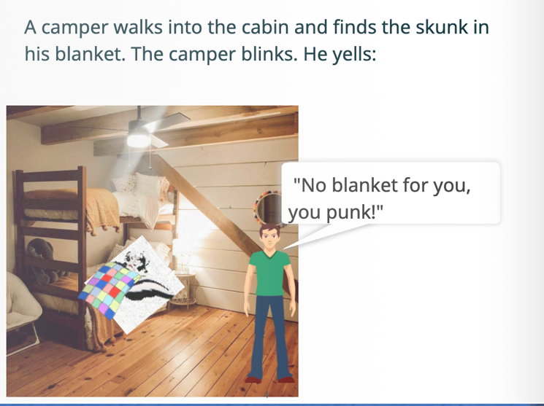

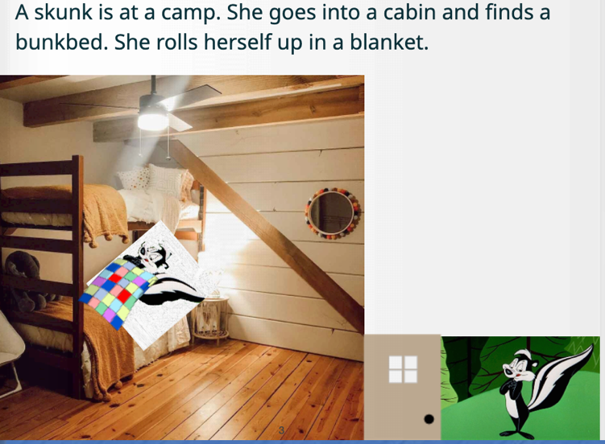

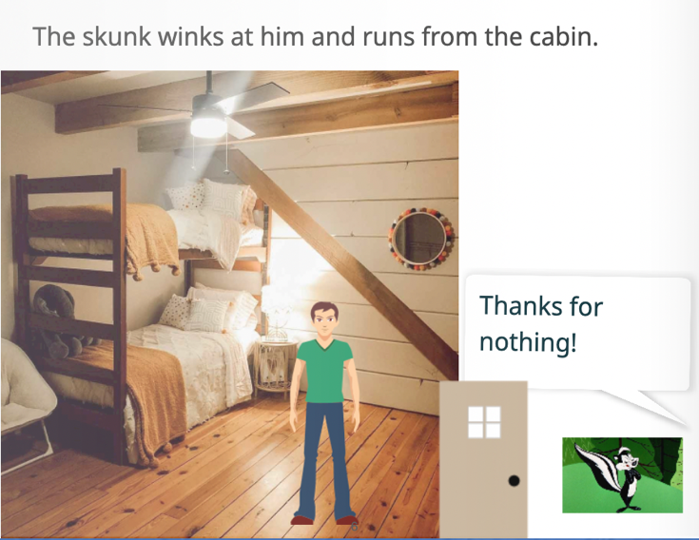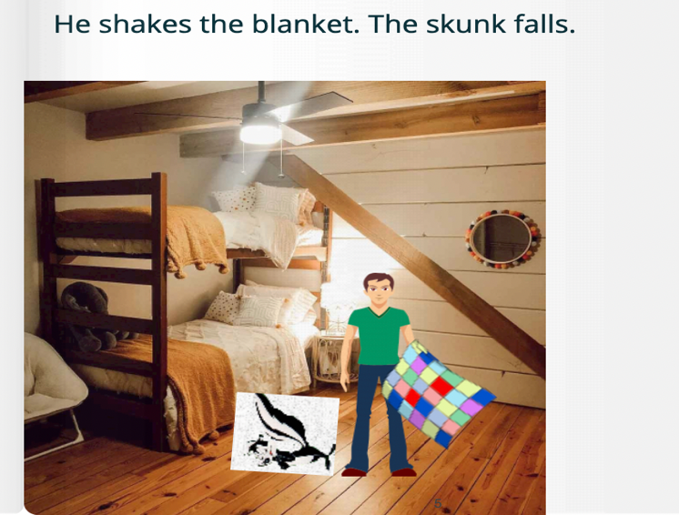

**Word list:**

|  |  |  |  |
| --- | --- | --- | --- |
| 1 |  | skunk |  |
| 2 |  | camp |  |
| 3 |  | cabin |  |
| 4 |  | blanket |  |
| 5 |  | bunkbed |  |
| 6 |  | blinks |  |
| 7 |  | thanks |  |
| 8 |  | thinks |  |
| 9 |  | winks |  |
| 10 |  | run |  |

Link to an online game, matching words to pictures:

<https://wordwall.net/resource/65466342>

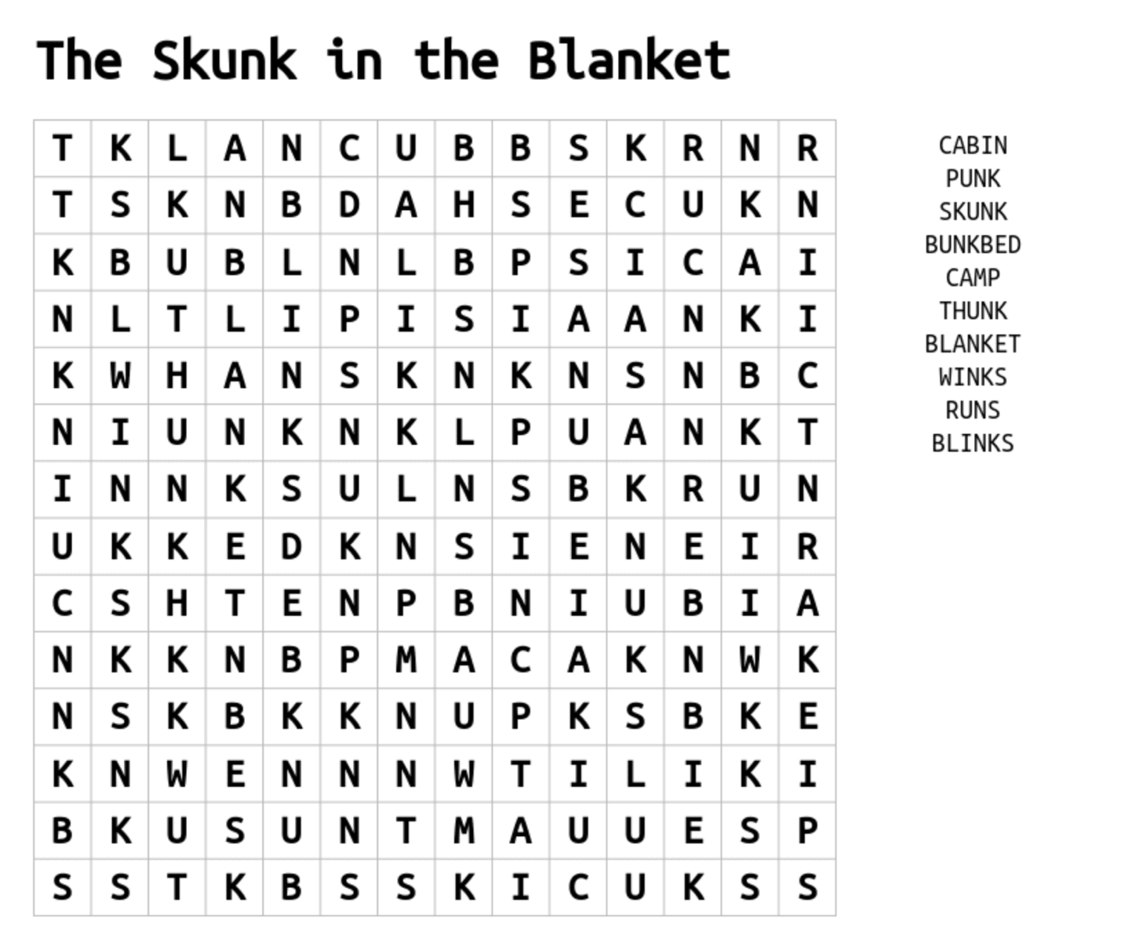

Fill in the blanks:

The _______ in the Blanket

A skunk is at a camp. She goes into a ____ and finds a bunkbed.

She rolls herself up in a ______.

A camper walks into the cabin and finds the skunk in his blanket.

The camper ______. He yells, "No blanket for you, you ______!"

He shakes the blanket. The skunk falls out. _____!

The skunk _____ at him and runs from the cabin.

Word bank: thunk, blinks, skunk, blanket, winks, cabin, punk.