The Painting Competition
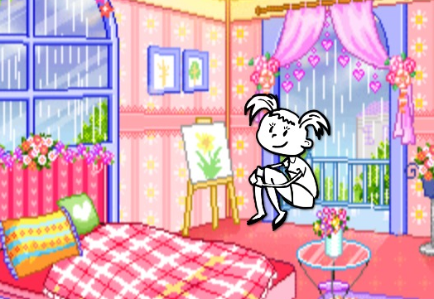  Rena's life ambition is to become a painter. She is very talented and has a great imagination. | 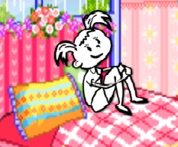  Her plan was to participate in a painting competition next week. But the night before the competition she couldn’t fall asleep.
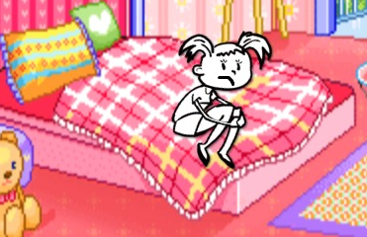  When she woke up in the morning, she found out she was late. "I will never get to the bus station on time!" she told her mother. | 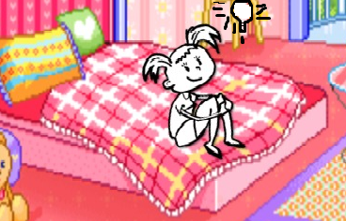  Rena tried to think of a good solution to the situation. She realized there was only one option. She would take a cab.
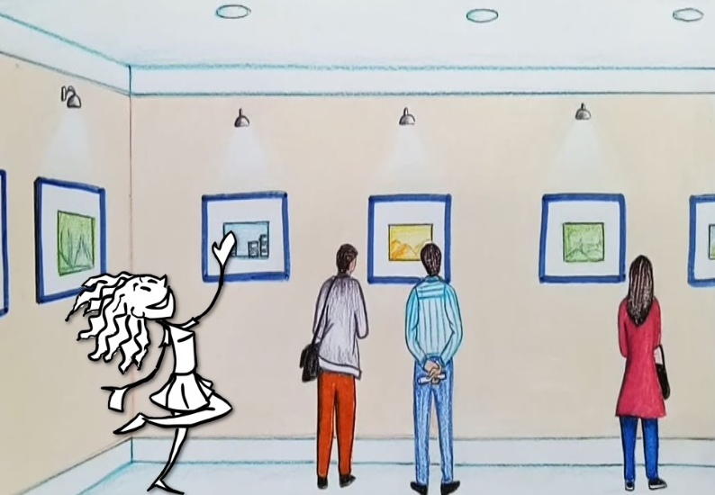  Finally, she arrived at the painting competition. |   Her mother told her: "There is no question, you made the best creation".

Word List
1 |  | ambition
2 | 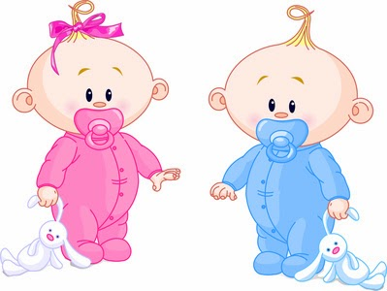 | babies
3 |  | competition
4 | 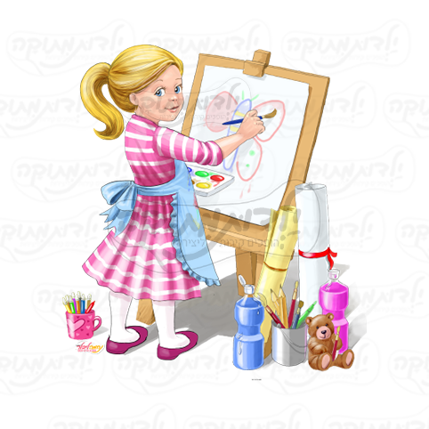 | creation
5 |  | families
6 |  | imagination
7 |  | option
8 | 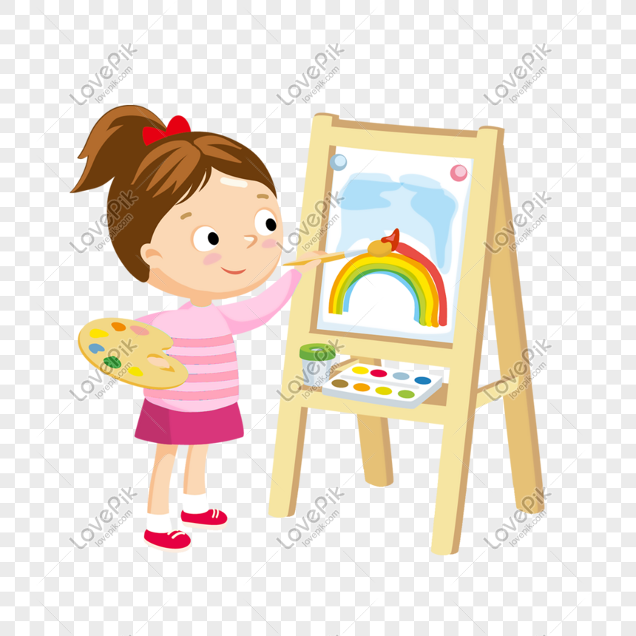 | painting
9 |  | question
10 | situation | situation
11 |  | solution
12 | 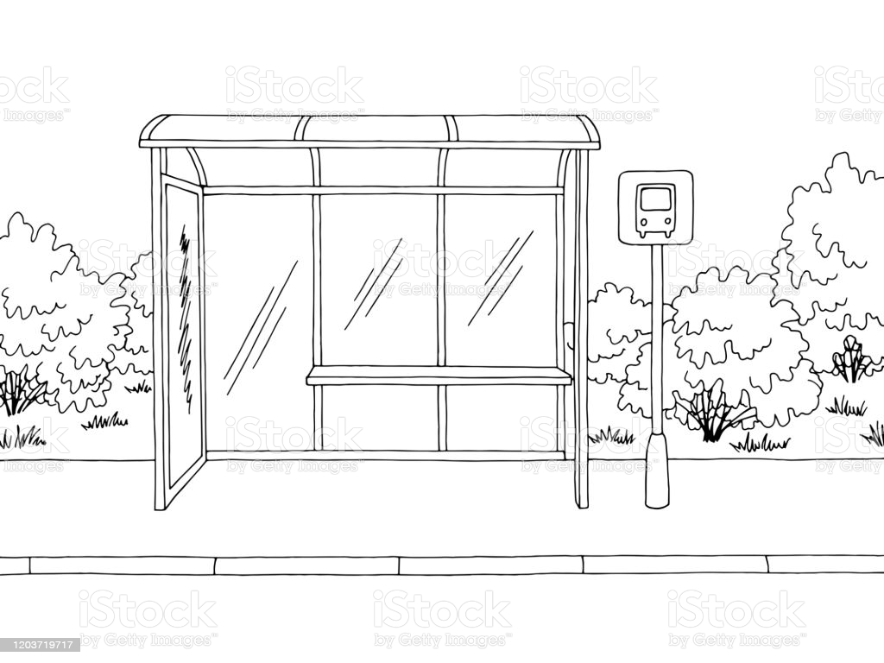 | station

Word Search Puzzle:

a | b | n | i | c | d | b | g | f | q | h | i | j | k
f | l | o | m | m | n | o | a | o | p | t | i | o | n
a | c | i | p | q | a | r | s | b | t | u | v | s | w
m | r | t | x | a | y | g | z | a | i | b | c | i | d
i | e | i | n | e | i | k | i | l | m | e | n | t | o
l | a | t | o | r | s | n | t | n | u | v | s | u | w
i | t | e | i | z | h | x | t | y | a | q | z | a | a
e | i | p | t | o | j | a | w | i | m | t | p | t | m
s | o | m | a | t | q | i | f | e | n | l | i | i | b
f | n | o | t | e | f | z | b | a | b | g | y | o | i
k | g | c | s | h | a | m | b | i | t | i | o | n | n
t | i | o | n | c | r | e | a | b | g | r | s | a | b
h | v | h | n | o | i | t | s | e | u | q | k | j | d
a | g | f | e | d | s | o | l | u | t | i | o | n | c

- ambition
- babies
- competition
- creation
- families
- imagination
- option
- painting
- question
- situation
- solution
- station

