Yetta and the Cat
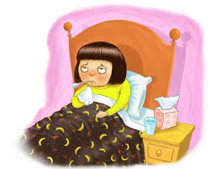  Yetta is sick in bed. Her eyes are sad. | A kind kid Ben is there at her bed.  He has kittens. They are in a basket.  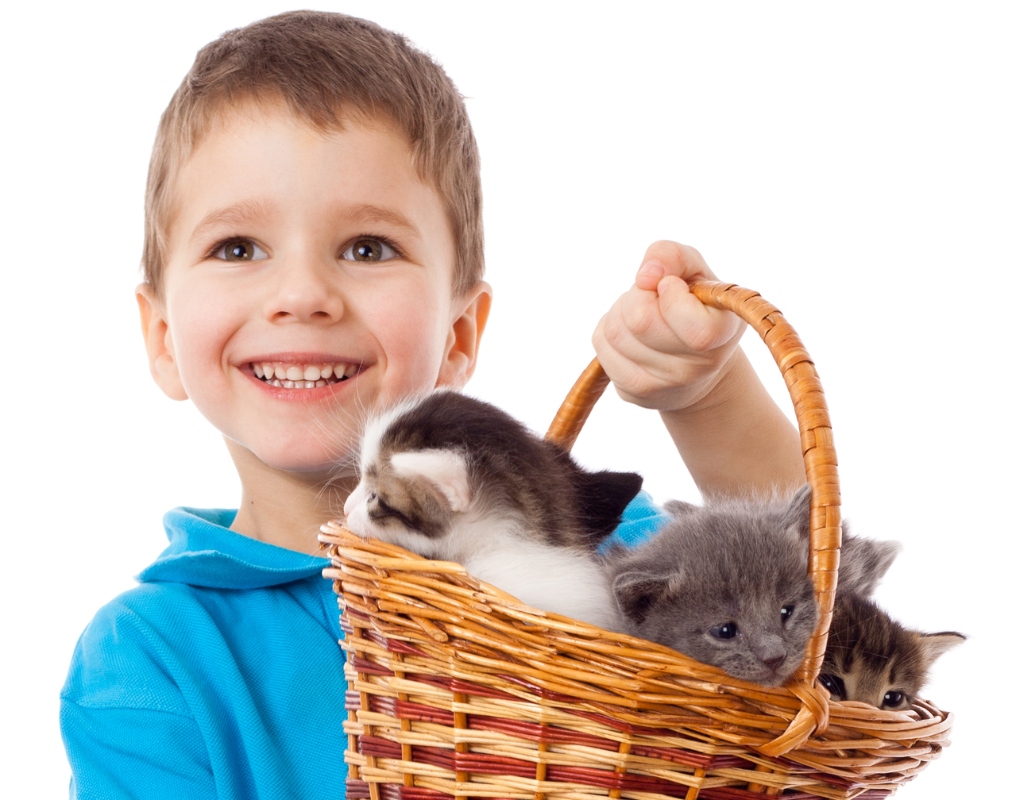  Can I pick a kitten?
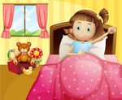  She sat in bed. She said,  “Yes ! Pick me a kitten.” | 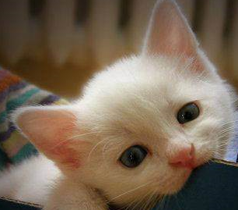  Ben picks a cat. It’s in his basket.  “This kitten?”
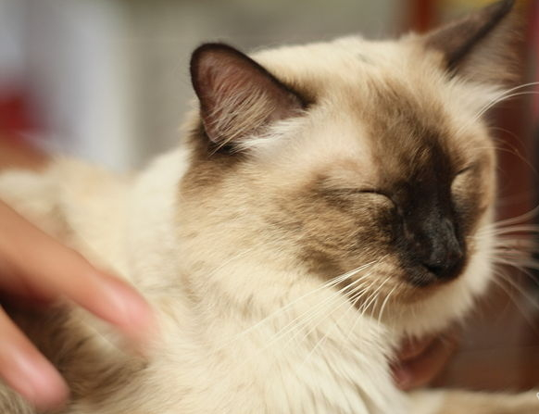  “Yes! Yes! That kitten!”  Yetta pats the cat’s neck.  Her hand pats her cat. |   Yetta rests. Her eyes aren’t sad!  Yetta isn’t sick.

Word List
1 |  | Yetta
2 |  | yes
3 |  | eyes
4 |  | they
5 | 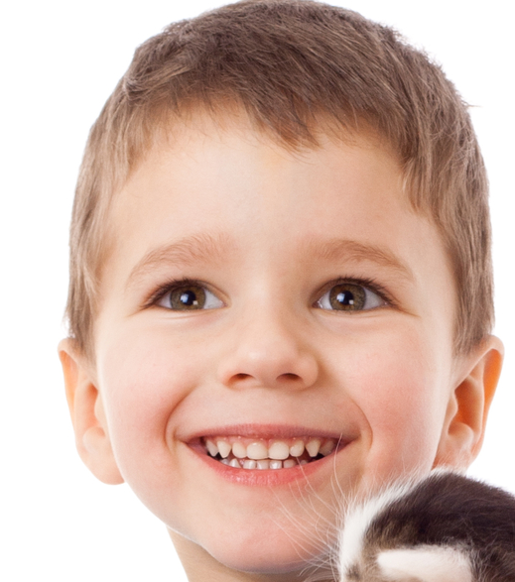 | kid
6 |  | sat
7 |  | kitten
8 | 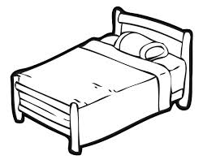 | bed
9 | 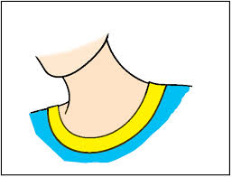 | neck
10 | 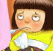 | sick
11 | 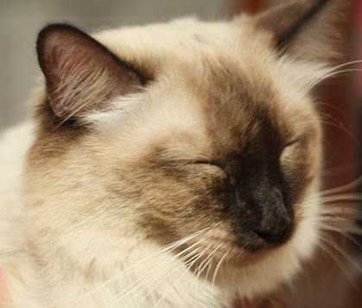 | cat
12 | 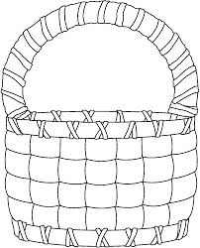 | basket

Game: Describe and Caption the Pictures

Cut up the story, cutting apart the pictures and their texts.

You can use the story text or prepare new captions for the pictures, such as:

Yetta is sick in bed

A kind kid Ben has kittens

Yetta sat in her bed

Ben picks a kitten

Yetta pats her cat’s neck

Yetta isn’t sick

Glue pictures and captions / story text onto stiff paper (lamination optional).

Students choose a picture. They need to describe the picture in their own words. Then they need to match the correct caption to each picture.

