A Musician or a Magician?
Dan is eight and he loves music.  “Perhaps one day I’ll be a musician.”  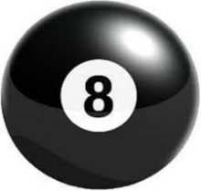 | Thinking about it he says  “But I also love magic, so perhaps I’ll be a magician.”
“What should I do?” he asks his neighbor Bill the electrician.  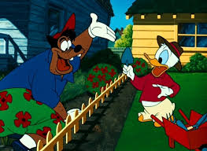 | “Music and magic are fun” says Bill, “but I think you should follow my tradition and become some kind of technician.”  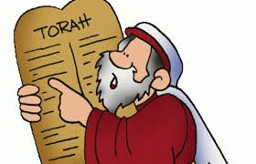
“No thanks, Bill. That’s not for me. Perhaps my father the physician can help me to decide.” | “Dad, what should I be, a musician or a magician?”  “Son, like me you need a profession with a good pension. I think you would be a wonderful pediatrician or obstetrician.”
Shaking his head, he whispers to himself “it’s time to ask Mom the politician.”  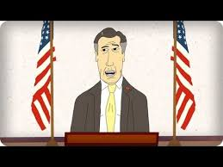 | “Mom, what should I do? I can’t decide. Should I be a musician or a magician?”  Smiling she says, “Dan, you should be a musical magician.”  Smiling back at his mother he says, “Mom, I always like your advice.”

Word List
1 | 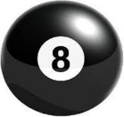 | eight
2 |  | musician
3 |  | magician
4 |  | neighbor
5 |  | electrician
6 |  | tradition
7 |  | technician
8 |  | physician
9 |  | profession
10 |  | pension
11 |  | pediatrician
12 |  | politician

Game: Word Search - sh’n sound
Find 9 words that end in the sh’n sound and circle them.
Make sure to choose the proper ending – cian, tion or sion – for each word.
Be careful, it’s a bit tricky!

s | h | o | k | s | t | e | c | h | n | i | t | i | o | n
e | l | e | c | t | r | i | t | i | o | n | n | a | j | m
m | u | t | g | f | a | w | g | z | i | o | n | l | r | t
u | p | o | l | i | t | i | t | i | o | n | s | c | h | a
s | s | d | r | a | e | f | f | y | c | b | y | n | q | u
i | m | a | g | i | c | i | a | n | i | o | i | a | n | p
c | r | u | j | a | h | p | h | y | s | i | c | i | a | n
i | t | e | s | e | n | l | e | m | g | u | a | b | d | e
a | a | l | r | i | i | a | p | e | n | t | i | o | n | f
n | z | e | t | j | c | k | o | e | o | g | y | d | u | p
f | e | c | i | o | i | i | l | y | n | s | c | w | i | p
t | p | t | s | s | a | o | o | n | x | s | a | d | v | o
r | e | r | m | h | n | l | p | n | b | o | i | x | s | l
a | y | i | o | j | s | c | r | a | e | t | c | o | l | i
d | o | c | g | f | t | k | o | r | v | t | m | d | n | t
i | m | i | d | d | e | v | f | i | l | h | s | a | t | i
t | n | a | y | p | k | s | e | g | y | a | r | c | i | c
i | s | n | a | r | o | u | s | b | b | d | g | u | l | i
o | i | t | r | a | d | i | s | i | o | n | a | h | r | a
n | r | v | e | x | m | t | i | o | a | w | r | o | x | n
p | h | y | s | i | t | i | o | n | d | n | a | l | y | p
m | a | g | i | t | i | o | n | s | e | d | r | e | i | m

Answer key:

s | h | o | k | s | t | e | c | h | n | i | t | i | o | n
e | l | e | c | t | r | i | t | i | o | n | n | a | j | m
m | u | t | g | f | a | w | g | z | i | o | n | l | r | t
u | p | o | l | i | t | i | t | i | o | n | s | c | h | a
s | s | d | r | a | e | f | f | y | c | b | y | n | q | u
i | m | a | g | i | c | i | a | n | i | o | i | a | n | p
c | r | u | j | a | h | p | h | y | s | i | c | i | a | n
i | t | e | s | e | n | l | e | m | g | u | a | b | d | e
a | a | l | r | i | i | a | p | e | n | t | i | o | n | f
n | z | e | t | j | c | k | o | e | o | g | y | d | u | p
f | e | c | i | o | i | i | l | y | n | s | c | w | i | p
t | p | t | s | s | a | o | o | n | x | s | a | d | v | o
r | e | r | m | h | n | l | p | n | b | o | i | x | s | l
a | y | i | o | j | s | c | r | a | e | t | c | o | l | i
d | o | c | g | f | t | k | o | r | v | t | m | d | n | t
i | m | i | d | d | e | v | f | i | l | h | s | a | t | i
t | n | a | y | p | k | s | e | g | y | a | r | c | i | c
i | s | n | a | r | o | u | s | b | b | d | g | u | l | i
o | i | t | r | a | d | i | s | i | o | n | a | h | r | a
n | r | v | e | x | m | t | i | o | a | w | r | o | x | n
p | h | y | s | i | t | i | o | n | d | n | a | l | y | p
m | a | g | i | t | i | o | n | s | e | d | r | e | i | m

