Can I Sleep at Jeff's?
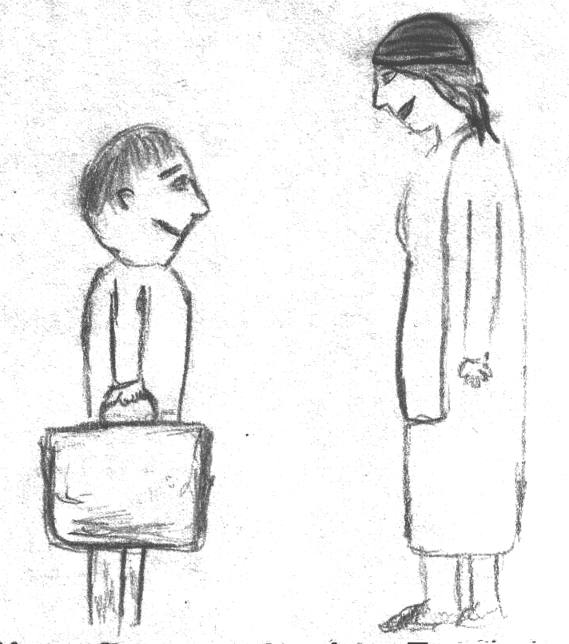  "Mom, I was invited to sleep at Jeff's. Can I go?" | 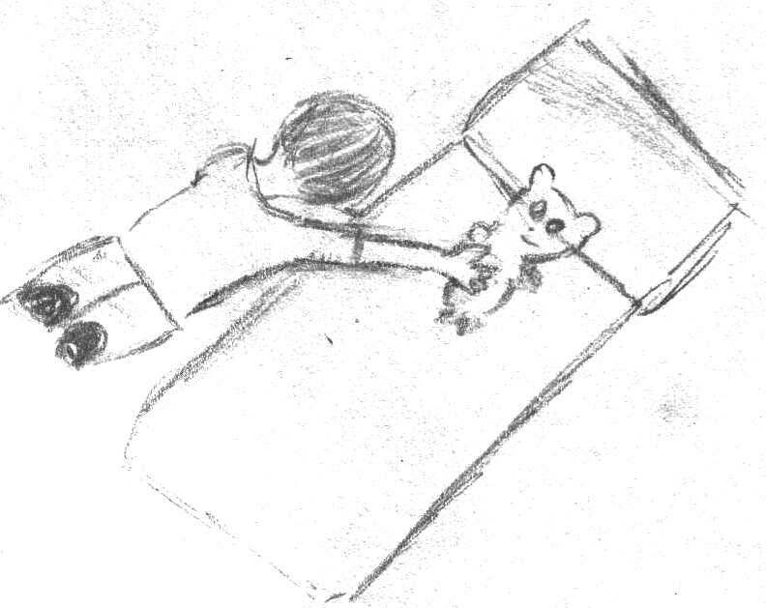  "Can you fix your bed?"  "O.K., I fixed my bed."
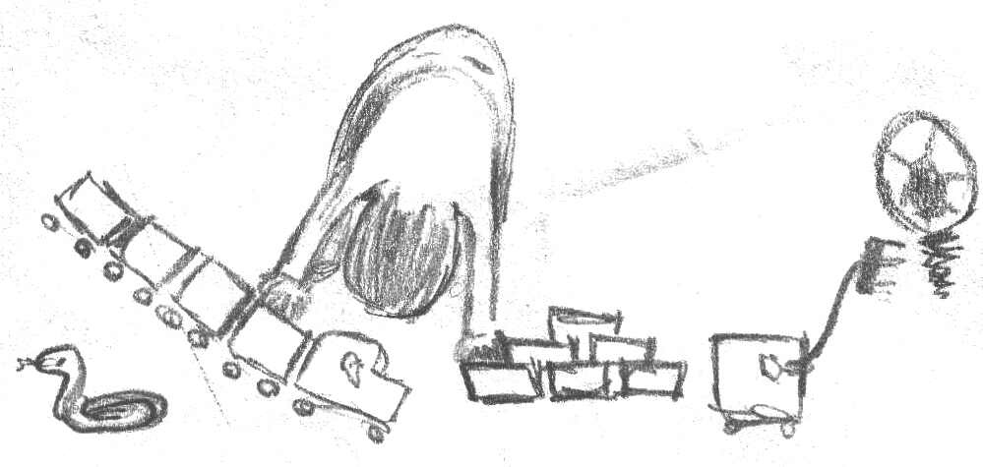  "Can you pick up your things?"  "O.K., I picked up my things." | 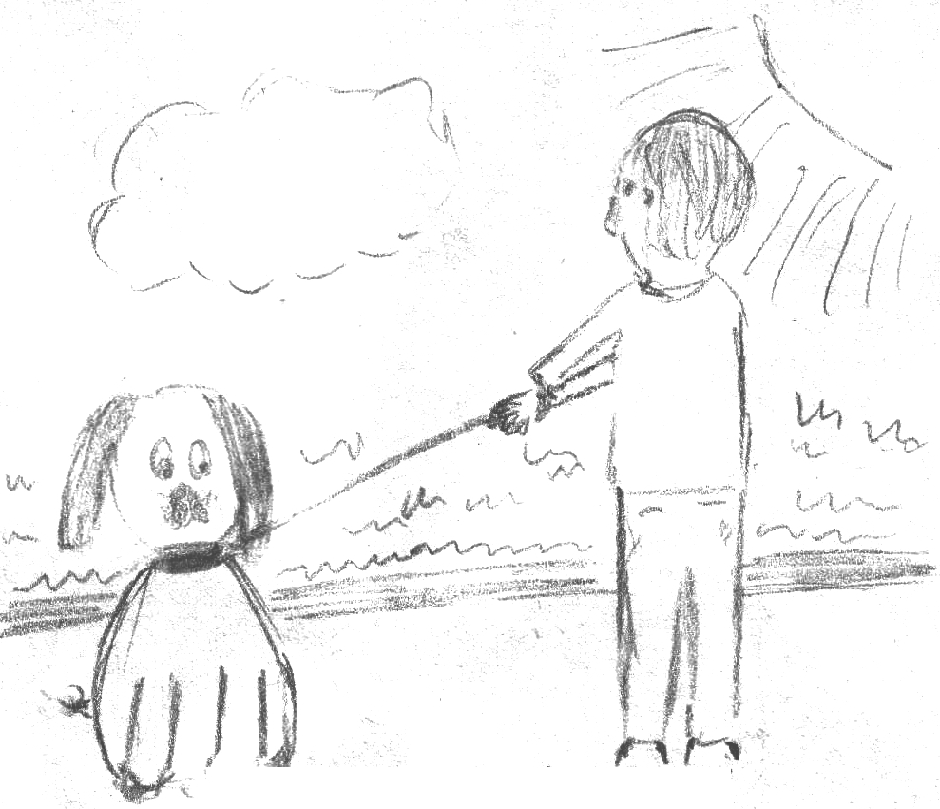  "Can you walk the dog?"  "O.K., I walked the dog."
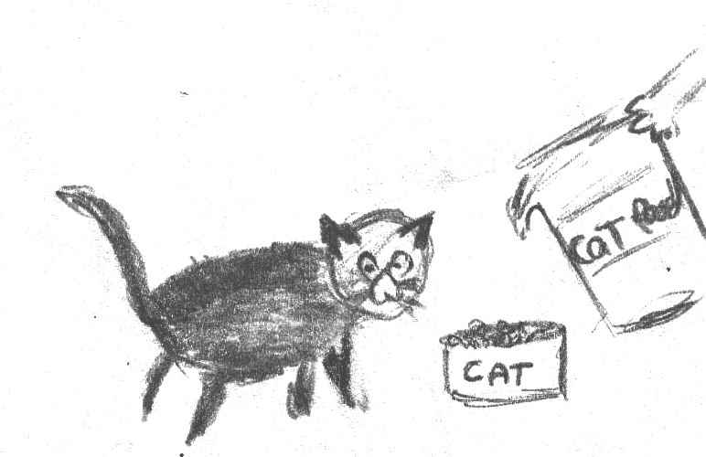  "Can you feed the cat?"  "O.K., I fed the cat." | 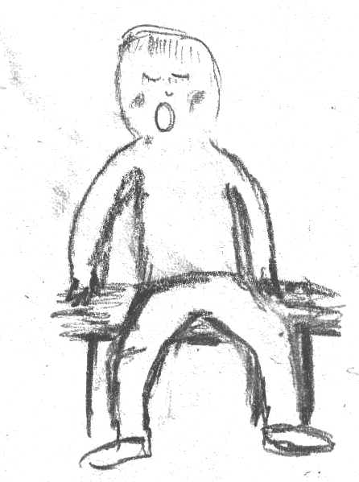  "O.K., you can go."  "No, I can't. I feel too tired.  I want to sleep!"

Word List
1 | 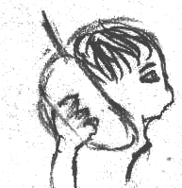 | invited
2 | 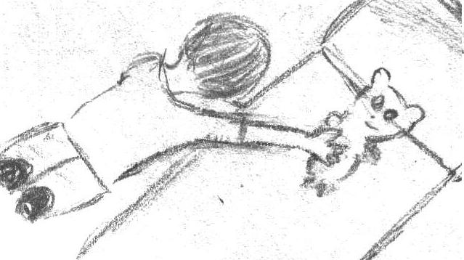 | fixed
3 | 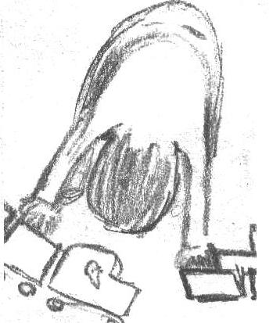 | picked up
4 | 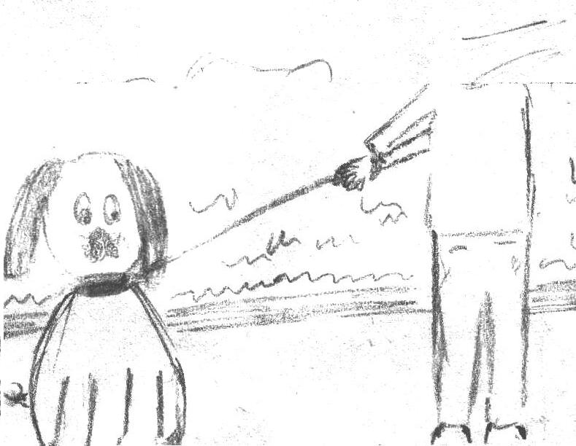 | walked
5 | 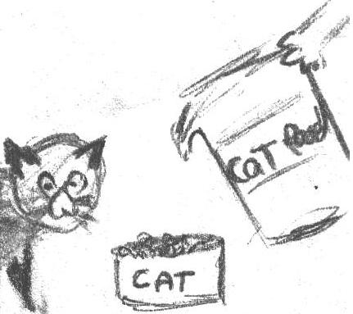 | fed
6 |  | sleep
7 | 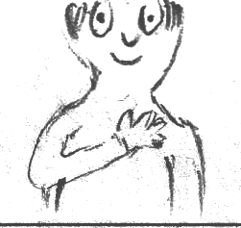 | feel
8 | 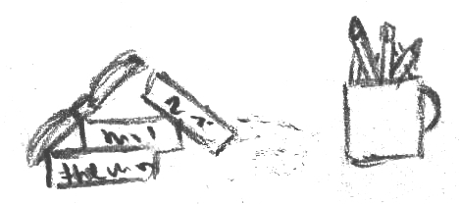 | things
9 |  | Mom
10 |  | O.K.
11 | 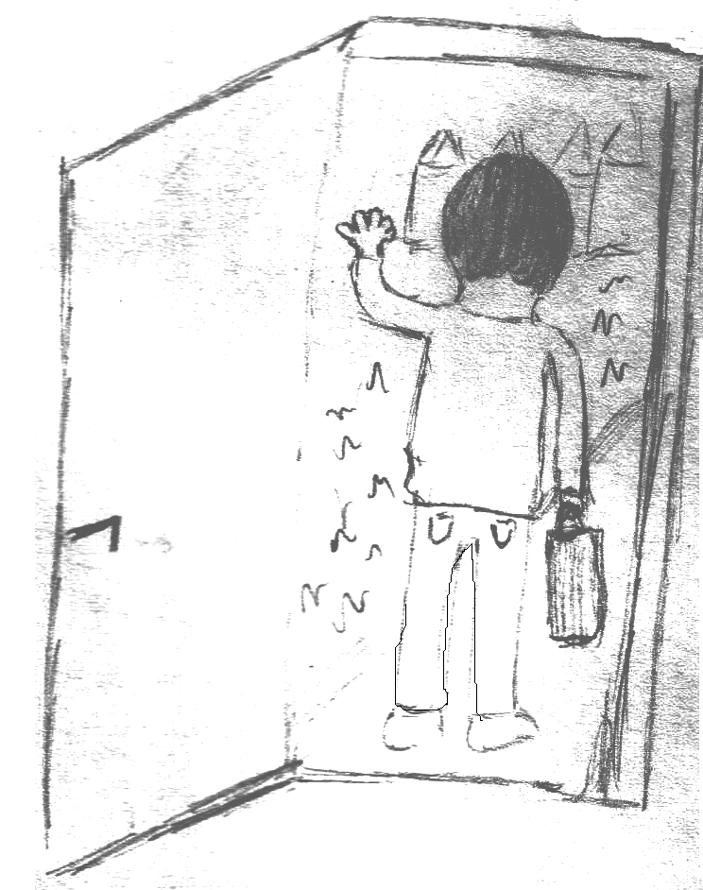 | go
12 |  | bed

1  kicked | 2  played | 3  talked | 4  helped | 5  baked | 6  stopped
1  wanted | 2  started | 3  invited | 4  tested | 5  visited | 6  smiled
1  added | 2  tasted | 3  listened | 4  liked | 5  packed | 6  hiked
1  walked | 2  jumped | 3  splashed | 4  camped | 5  fished | 6  cooked
1  reminded | 2  picked | 3  fixed | 4  played | 5  filled | 6  yelled
1  planned | 2  needed | 3  called | 4  rested | 5  handed | 6  rented

Game

Instructions

Four in a Row game for 2 players
You will need:
Attached board, preferably laminated.
One die
Colored counters for each player, approximately 20
How to Play:
- Roll the die.
- Read a word with the same number as the die.
- Place one colored counter on the word if read correctly.
- The winner is the first one to have 4 in a row either vertically, horizontally or diagonally.

Created by Billy Reid Derry Reading Centre Northern Ireland

