Sam Brings Food to the Pool
  - Sam sits at his desk at school.  Sam is hot and hungry.  Sam’s mood is bad. | 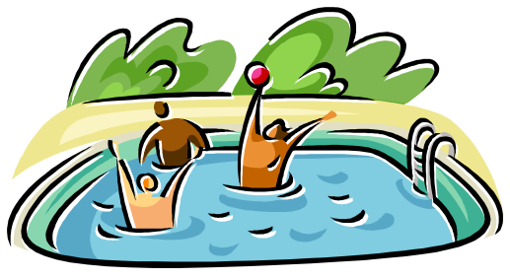  2. Finally school ends.  Sam runs with Dan to the pool.
  - Sam buys food with a spoon.  Sam takes his food and spoon  next to the pool. | 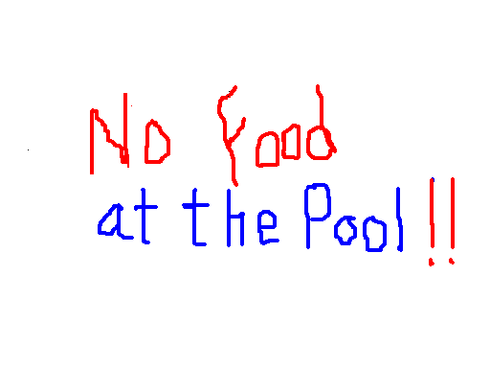  4. Dan tells Sam. “Look!  NO FOOD AT THE POOL!”
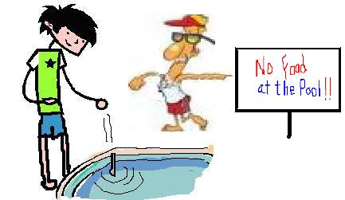  5. Sam drops his spoon in the pool.  The pool man tells Sam, “Kids with  food at this pool aren’t cool.  Go home, Sam. You broke the  no-food-at-the-pool rule!” | 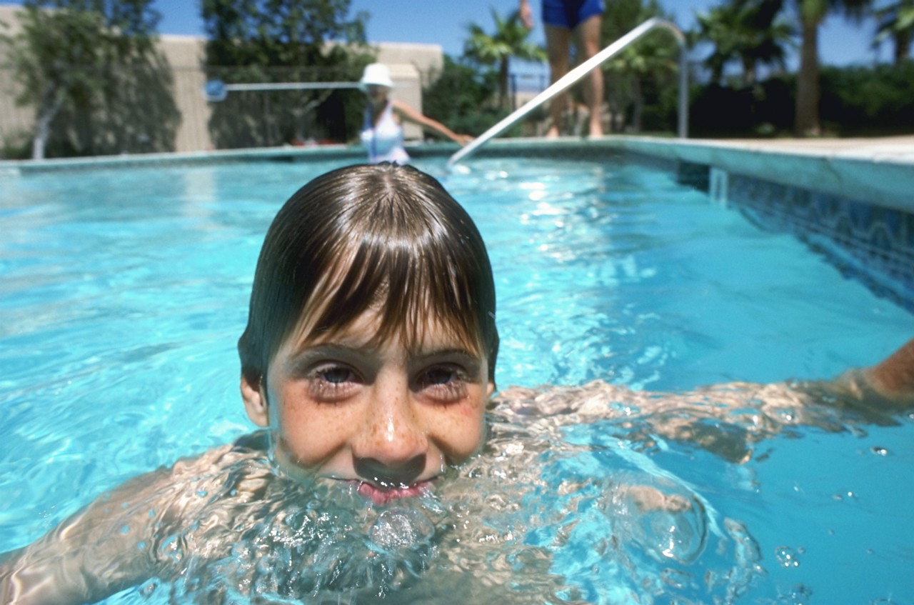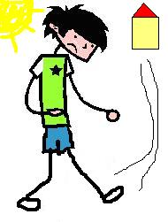  6. Dan swims. Hot Sam walks home.

Word List
1 | 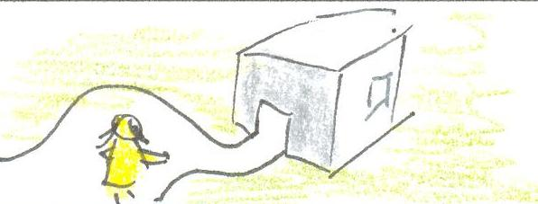 | school
2 | 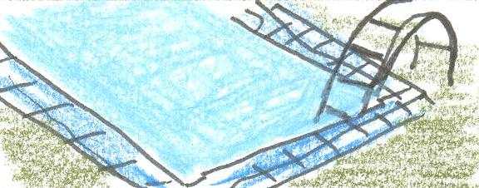 | pool
3 | 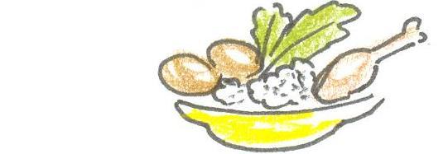 | food
4 | 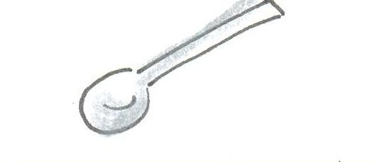 | spoon
5 | 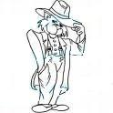 | cool
6 | 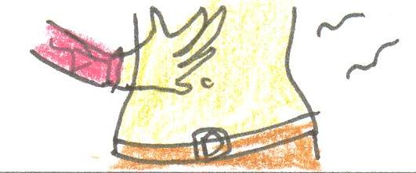 | hungry
7 | 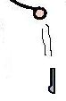 | drop
8 | 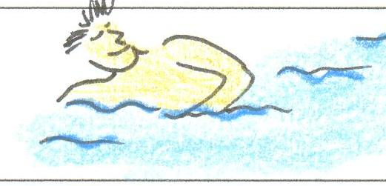 | swim
9 | 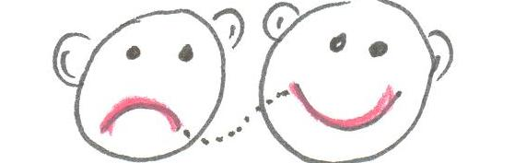 | mood
10 | 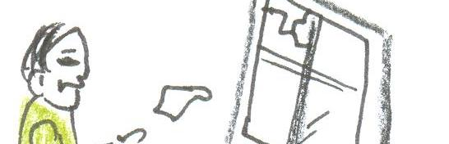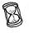 | broke
11 | 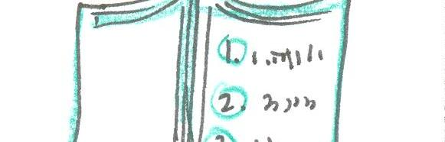 | rule
12 | 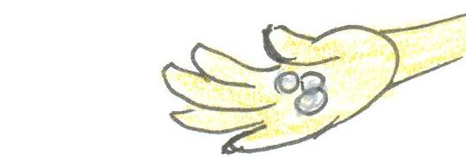 | buy

Ruler Matching Game:
- Empty the “sargel m’shulav” numbers out of the clear tray. Place the tray over the words.
- Find the picture to match each word, and place its number over the word in the tray.
- Check yourself: slide in the ruler cover, turn over, and compare to the diagram.
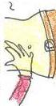 | 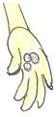 |  | buy | school
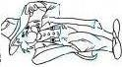 | 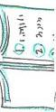 |  | spoon | swim
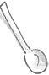 | 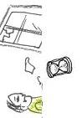 |  | cool | food
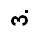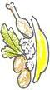 |  |  | rule | mood
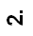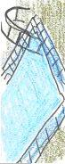 | 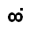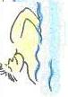 |  | drop | pool
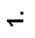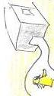 | 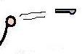 |  | hungry | broke



