Horizontal and Vertical
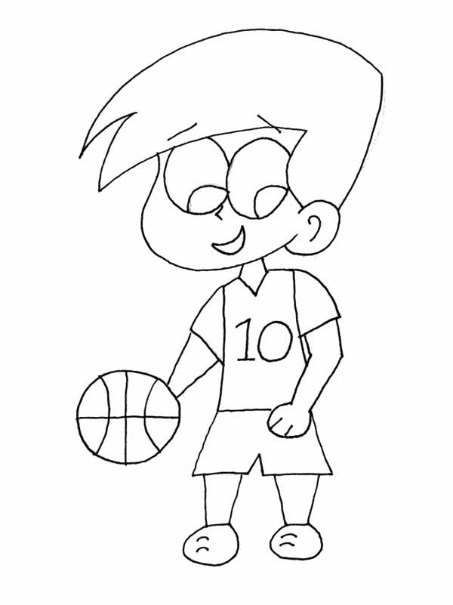  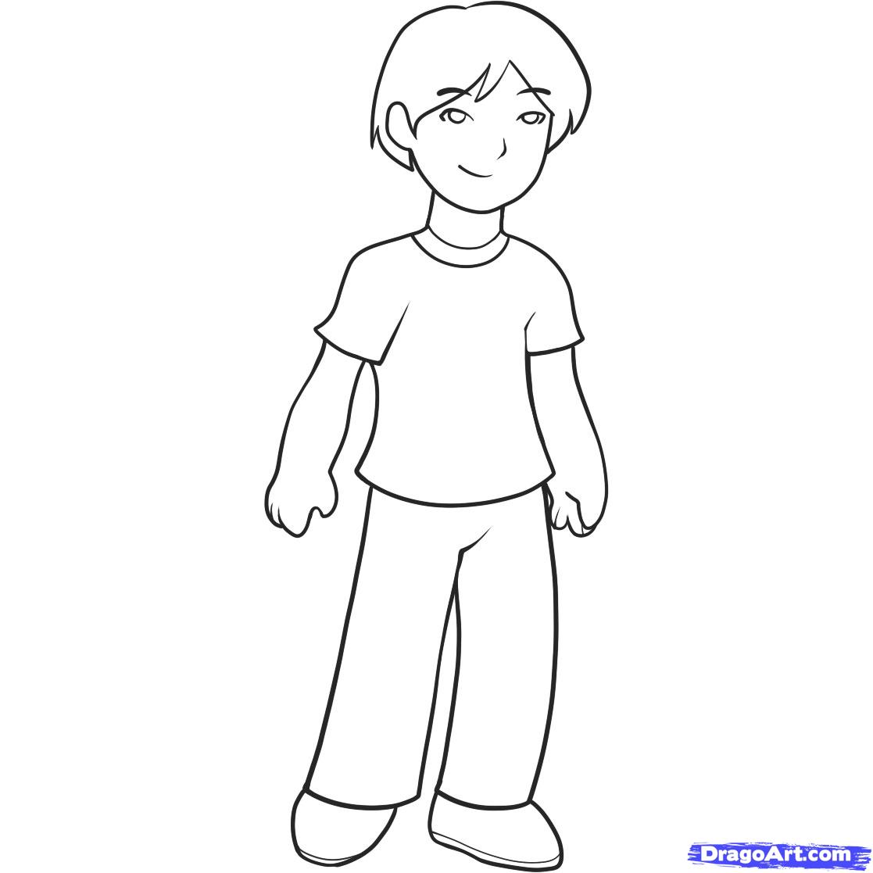  Wow, Dan  you are so tall!  Yes.  I am tall  and it is known to all! | 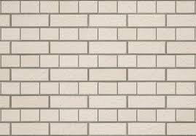    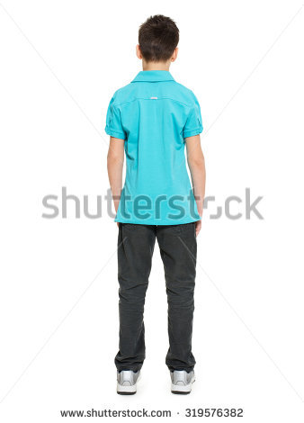  Can you climb the wall?  I think I can.  I hope I will not fall.  Come on Dan. Try to climb the wall. Don't stall!
Give me a second, Ben. I just ate a schnitzel and meat balls at the mall, and they weren't small.  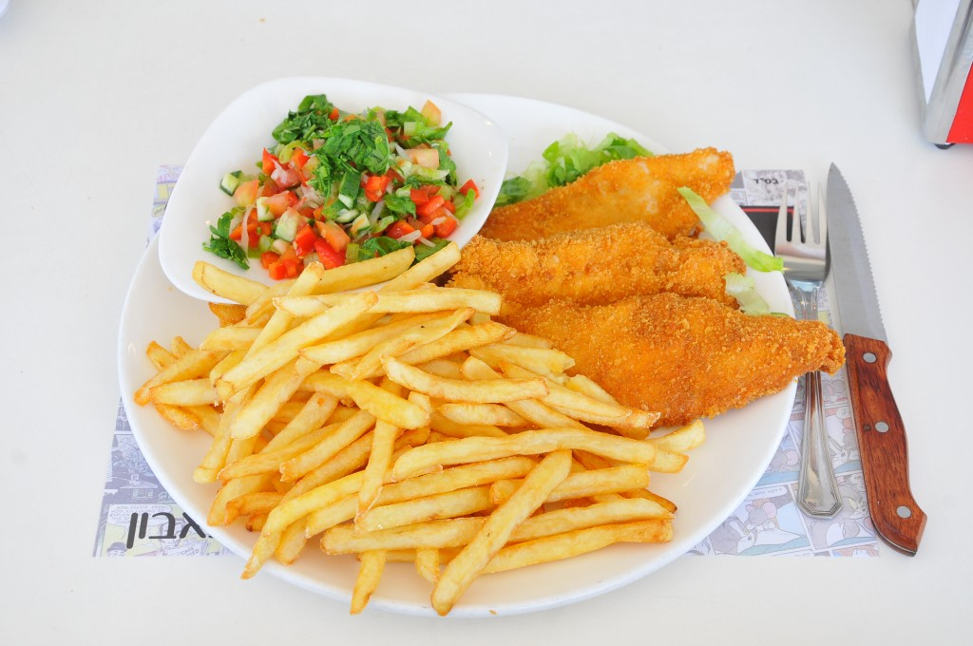  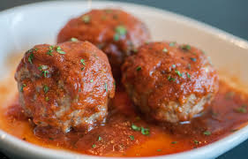    Oh Dan. Excuses, excuses. |   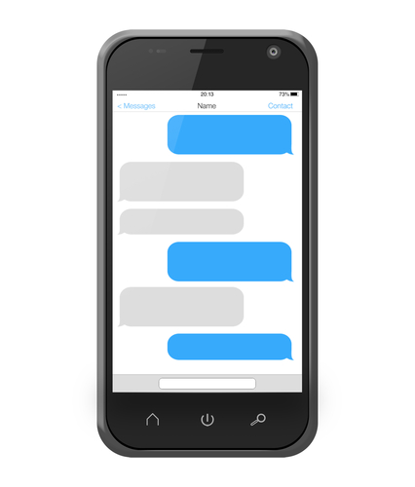  You know what Ben?  I don't feel so well. I think I'll go home now and lie down in a horizontal position .for an hour or so..  You're afraid, ah? OK. Call me when you get back to a vertical status.  Ok. I guess I'll text you when I get up.
  All your talk of food has made me hungry. I think I'll go buy myself a good Falafel  Haven't you already eaten? I saw you earlier with a big pretzel! | Oh. That was just a snack. I haven't eaten my official lunch yet.  So typical… OK. Talk to you later. Good appetite, Ben.  Thanks! Feel well, Dan!

Word List
1 |  | mall
2 | 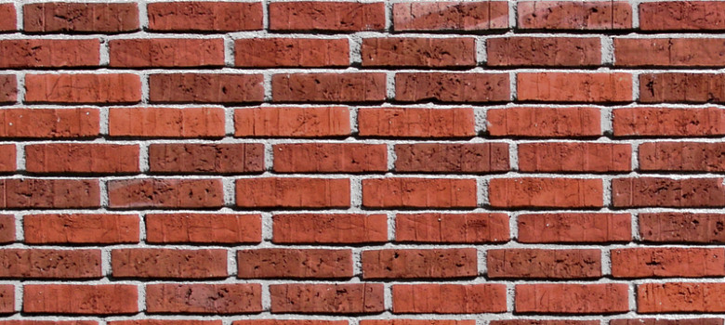 | wall
3 | 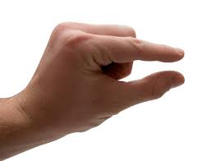 | small
4 | 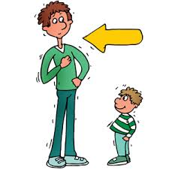 | tall
5 | 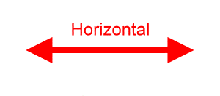 | horizontal
7 | 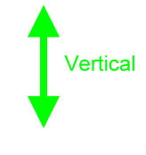 | vertical
8 |  | Call
9 | 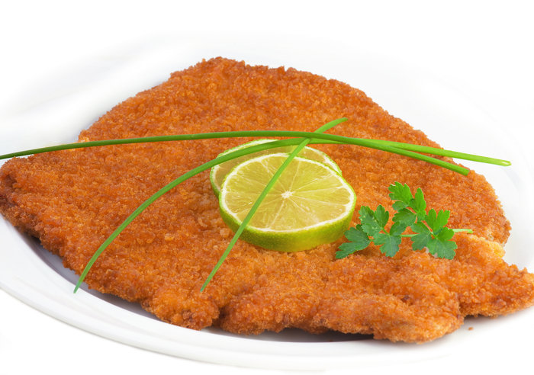 | schnitzel
10 |  | ball
11 |  | meatballs
12 | 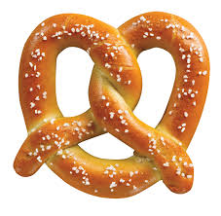 | pretzel
13 | 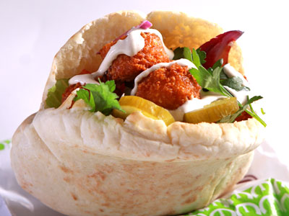 | falafel

Lesson 86a
Word Search

O U C T L C G C X L V E Q Q Y
T Y T L O C A O A D E D P Q E
D J A H X L L T K R R Q T C X
F T L W L Z N U G M T O A S V
S Q P S A O S C H N I T Z E L
V S J S Z L B Q B S C I P O G
M W V I M A L L L Y A J F V Y
B E R L A C I P Y T L F N J Q
L O A I Y G Q R J I I L L A B
H E L T Z E E Y C C D X H S T
F Z F L B D L O I L T R A X T
O G W A A A L A E L A N Z G G
U R Y E L M L T X A L D D L C
A K Y V J A D L V M L E L S Y
N U V K E Z F D S S N K T X F

Words:
ALL
BALL
CALL
FALAFEL
HORIZONTAL
MALL
MEATBALLS
OFFICIAL
SCHNITZEL
SMALL
STALL
TALL
TYPICAL
VERTICAL
WALL

