Instructions: How to create a Ruler Game from a Lesson Word List

The unique, fun feature of this "game" is that students have pieces they can manipulate
and a simple, graphic answer key with which to check themselves.

The "ruler" is made by Israeli company "Gan Li" and can be purchased at a shop that carries educational materials for preschoolers. (It's called a קלמר שילוב and can also be ordered from http://www.gan-li.co.il/קלמר-שילוב. שילוב is the initials of -שחק למד ובדוק Play, Learn, Self-check.)
It looks like this | You can arrange it in different ways, like this (template 8) | and this (template 2).
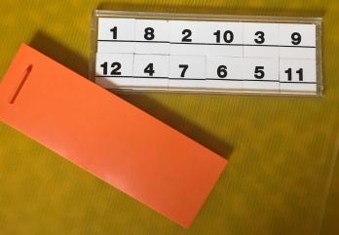 | 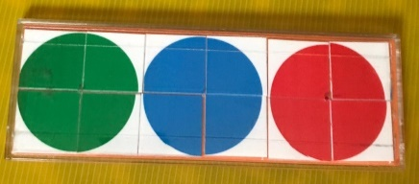 | 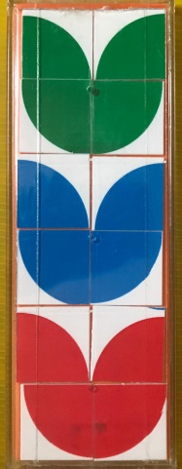
To make a game from a word list:
1. Save each picture in the 12-word word list in an individual graphics file.

2. To make up your own template: Using your "kalmar shiluv" ruler game, arrange the 12 tiles in the clear plastic tray so that the colored side makes a design you like and that you can draw and color at the bottom of the sheet.

3. The template is a Word table, with the typing direction "sideways." Type the twelve words from the word list into the lower table of Template 1 (the one without the numbers).

4. Using the numbers arranged in the plastic tray as a placement guide, "Insert" the individual pictures into the upper half of the template (the part with the numbers).
- Look at the first word in the upper row you typed in the template. Now look at the tile in the same position in the tray, and note its number.
- In the upper half of the template, locate that number, and insert the matching picture file into that numbered cell of the table, "Rotate" it 90 degrees counter-clockwise, and adjust its size so it fits into the square.
For example: if the first word in the upper-left corner is "tree", and that spot in your tray holds number 8, insert the picture of the tree into the upper template in cell 8.
- Continue until you have inserted all 12 pictures into their numbered cells.

5. Using Paint.net or another graphics program, draw the solution and copy it to the bottom of your game sheet.

6. Save and print your game sheet, and test it by following the directions on how to play the ruler game to make sure that your solution matches the placement of the words and pictures.

If you prefer, and you have a color printer, you can use any of the templates on the following pages to create a ruler game. Type the word at the blue number and insert the picture (and rotate it) in the square with the matching black number.

See the end of this document for illustrations on how to play the game. Good luck!

 |  |  | 4 | 8
 |  |  | 1 | 12
 |  |  | 6 | 10
 |  |  | 2 | 7
 |  |  | 11 | 9
 |  |  | 3 | 5
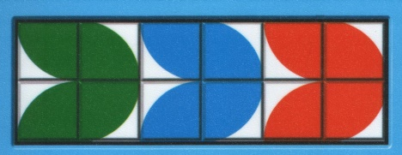

 |  |  | 12 | 1
 |  |  | 4 | 8
 |  |  | 5 | 3
 |  |  | 11 | 9
 |  |  | 7 | 2
 |  |  | 6 | 10
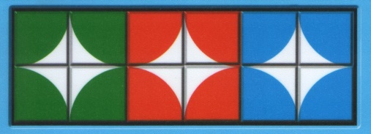

 |  |  | 9 | 4
 |  |  | 3 | 12
 |  |  | 10 | 6
 |  |  | 2 | 7
 |  |  | 1 | 11
 |  |  | 8 | 5
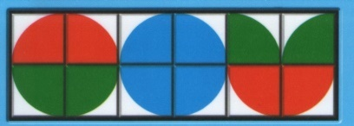

 |  |  | 12 | 11
 |  |  | 4 | 5
 |  |  | 10 | 9
 |  |  | 2 | 3
 |  |  | 7 | 1
 |  |  | 6 | 8
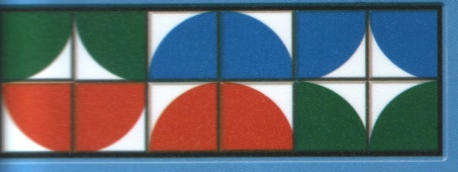

 |  |  | 11 | 9
 |  |  | 5 | 3
 |  |  | 6 | 10
 |  |  | 7 | 2
 |  |  | 4 | 8
 |  |  | 12 | 1
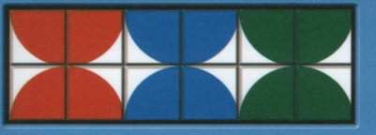

 |  |  | 4 | 8
 |  |  | 6 | 10
 |  |  | 2 | 9
 |  |  | 7 | 11
 |  |  | 5 | 3
 |  |  | 12 | 1
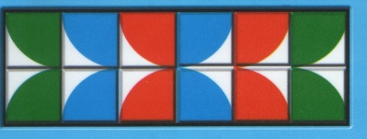

 |  |  | 9 | 11
 |  |  | 3 | 5
 |  |  | 10 | 6
 |  |  | 2 | 7
 |  |  | 8 | 4
 |  |  | 1 | 12
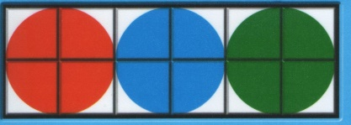

 |  |  | 3 | 11
 |  |  | 9 | 5
 |  |  | 4 | 8
 |  |  | 1 | 12
 |  |  | 10 | 7
 |  |  | 2 | 6
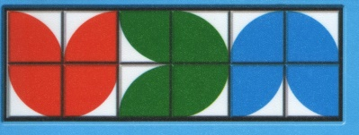

 |  |  | 1 | 12
 |  |  | 4 | 8
 |  |  | 9 | 5
 |  |  | 3 | 11
 |  |  | 7 | 2
 |  |  | 10 | 6
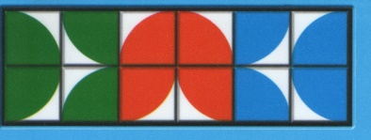

 |  |  | 5 | 3
 |  |  | 1 | 12
 |  |  | 8 | 7
 |  |  | 2 | 4
 |  |  | 9 | 11
 |  |  | 6 | 10
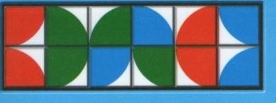

 |  |  | 4 | 5
 |  |  | 9 | 1
 |  |  | 2 | 10
 |  |  | 7 | 6
 |  |  | 3 | 8
 |  |  | 12 | 11
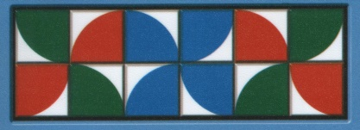

1) Empty the “sargel m’shulav” numbers out of the clear tray and place the tray over the words.
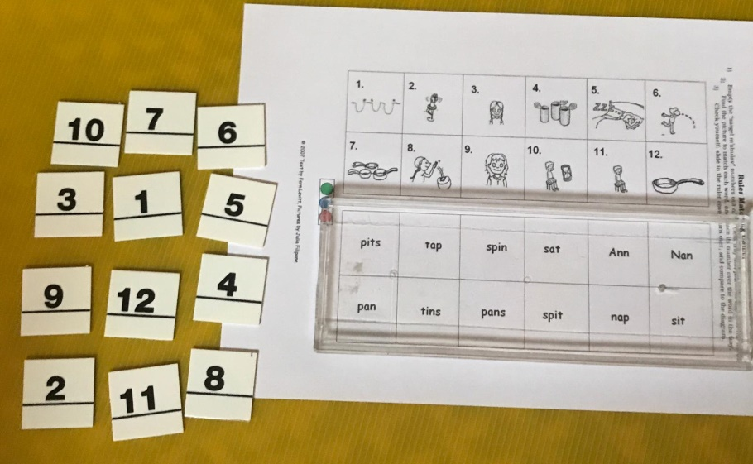

- Find the picture to match each word, and place its number over the word in the tray.
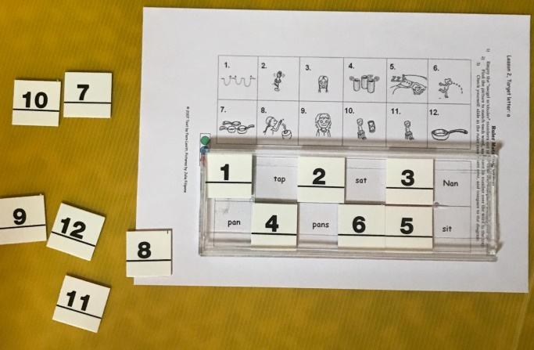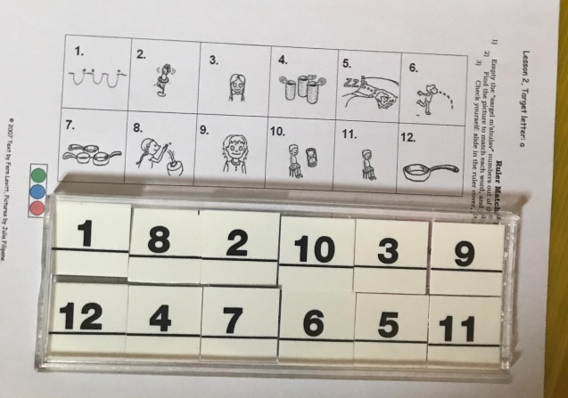

- Check yourself: slide in the ruler cover, turn over, and compare to colored Answer Key at the bottom of the page.
