Dan Traveled
In the summer, Dan arrived in Pisa. | In Pisa, Dan was bored,  so he wanted to travel by car.
He started to look for a car. He planned to drive to Rome. | He decided to buy a red Volvo.
Dan traveled with the red Volvo  to Rome. | He enjoyed Rome  and planned to visit Paris next!
Words
1 | 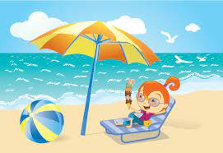 | summer
2 |  | Dan
3 | 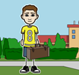 | arrived
4 | 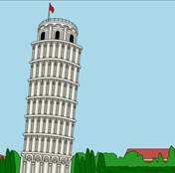 | Pisa
5 |  | bored
6 |  | wanted
7 |  | car
8 | 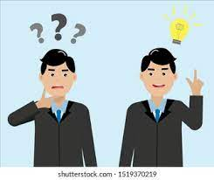 | decided
9 | 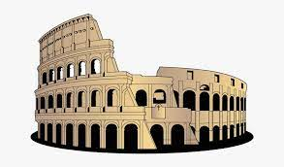 | Rome
10 | 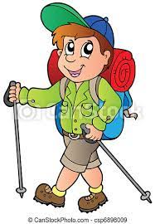 | traveled
11 |  | enjoyed
12 |  | planned
Online game: https://wordwall.net/resource/33364879
Games for matching pairs: Cut up cards and glue onto colored paper. Match the picture to the word. Game ideas: 1) Learner can simply look for pairs, 2) Play Concentration (cards face down, take turns turning over pairs to find matches),

summer | Dan | arrived
Rome | bored | wanted
car | decided | Pisa
traveled | enjoyed | planned

