Dan Retakes his English Test
Dan has many problems with the Wi-Fi. He disconnects and reconnects to the Wi-Fi. | 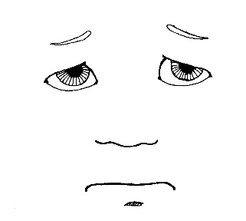  Dan is unhappy. He has to retake his English test online to correct it. He is unsure he can do this. His Wi-Fi has a lot of problems.
Dan tells his dad that he wants help with the Wi-Fi. Dan’s dad sits with him. Dad, unlike Dan, is not tired. Dad is sure they can connect to Wi-Fi so Dan can redo the English test. | 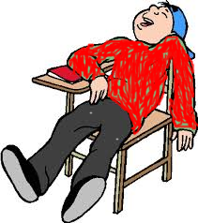  He has to redo his old test to fix his mistakes. He can fix the mistakes if he can connect to the Wi-Fi. But Dan is becoming tired just from trying to reconnect!
Then Dan prepares to go on a picnic with his dog. | Dad helps Dan fix the Wi-Fi. Dan can fix the mistakes and resubmit the test.

Word List
 | unhappy |  | 1
 | retake |  | 2
 | unsure |  | 3
 | disconnects |  | 4
 | reconnects |  | 5
 | redo |  | 6
 | mistakes |  | 7
 | becoming |  | 8
 | unlike |  | 9
 | sure |  | 10
 | resubmit |  | 11
 | prepares |  | 12

Online WORDWALL GAMES: FUN WITH PREFIXES
https://wordwall.net/resource/29196099
Have fun!

FUN WITH PREFIXES BOARD GAME
For 2-4 players
Equipment: Game board, 4 game pieces, dice
Instructions:
- Each player chooses one game piece and places it on Start.
- Players take turns rolling the dice and move their game pieces on the game board according to the number on the dice. To slow down the game, it can be played with only one die.
- Players progress towards Finish, following the instructions written on each square upon which they landed. If the square has an *, the player searches the cards (see below) for the prefix or word best matching the clue on the square. If players choose the wrong card, they must go back 3 squares. If they choose the correct card, they keep the card and await their turn to throw the dice/die.
- If a player has reached Finish and there are cards not held by any player, that player will go to Start and start over again. If they land on a square with an * and a different player already holds the card best matching the clue, they will be permitted to reroll the dice/die without having to wait their turn.
- The game is over when all the cards are held by the players. When all the cards have been chosen, the player holding the most cards wins.
- Cut out these cards:
re- | un- | unalike
mis- | resubmit | connect
retake | redo | unhappy
disconnect | unsafe | reopen
- The winner is the first to reach Finish. Have fun!

